# ATTACKS ON SEC CLINTON 5/7/16 – 5/13/16

## Table of Contents

EMAILS AND FBI

CAMPAIGN

SCANDALS

TRUMP’S THE BEST AT BEATING HILLARY!

MONEY, FRIENDS, AND DONORSCLINTON FOUNDATION

TRADE

HEALTHCARE

RECORD AS SECRETARY OF STATE

IRAN

SCOTUS

MILITARY

TAXES

HELPS PEOPLE

COAL

TRUMP

BACK TO TOP ↑

## Emails and FBI

**Sean Spicer Tweet** 5/6/16 5:30 PM

Read [Here](https://twitter.com/seanspicer/status/728698108293615617)

Hey What u up to next week? [@FBI](https://twitter.com/FBI/) interview with [@HillaryClinton](https://twitter.com/HillaryClinton/) could be in days [@thehill](https://twitter.com/thehill/) [thehill.com/blogs/ballot-b…](https://t.co/5IsX9CBkfl)

**Michael C. Short Tweet** 5/8/16 10:47 AM

Read [Here](https://twitter.com/michaelcshort/status/729321858051526656)

Security review? Lie. NYT: "FBI focus on whether disputed Clinton emails broke the law." [twitter.com/nytpolitics/st…](https://t.co/TA3GbsBCFZ) [twitter.com/FaceTheNation/…](https://t.co/hzWl1pNRAD)

[**Face The Nation** @FaceTheNation](https://twitter.com/FaceTheNation)

.[@HillaryClinton](https://twitter.com/HillaryClinton/) responds to the FBI inquiry into her email server: "It's a security inquiry. I always took classified material seriously."

**America Rising PAC Tweet** 5/8/16 11:00 AM

Read [Here](https://twitter.com/AmericaRising/status/729325079444623361)

Developing => FBI grills [@HumaAbedin](https://twitter.com/HumaAbedin/) about [@HillaryClinton](https://twitter.com/HillaryClinton/)’s email server [nyp.st/1TscDfq](https://t.co/mjywHrPU7h) via [@nypost](https://twitter.com/nypost/)

**America Rising PAC tweet** 5/8/16 11:44 AM

Read [Here](https://twitter.com/AmericaRising/status/729336214797438976)

Oh, Really? [@HillaryClinton](https://twitter.com/HillaryClinton/) Claims The FBI Still Hasn't Contacted Her: [bit.ly/23zpZfw](https://t.co/VYxwnQJWqn) [amp.twimg.com/v/227f9dce-f20…](https://t.co/9BB62gZPT4)

**FACT DC Tweet** 5/8/16 12:01 PM

Read [Here](https://twitter.com/factdc/status/729340356542668800)

.[@NBCNews](https://twitter.com/NBCNews/) Reports: Hacker 'Guccifer': I Got Inside [@HillaryClinton](https://twitter.com/HillaryClinton/)'s Server [nbcnews.to/1rwpiYN](https://t.co/fz7UPpItqa)

**RNC Research Tweet** 5/8/16 12:27 PM

Read [Here](https://twitter.com/RNCResearch/status/729347065713709056)

FACT CHECK: Clinton Misleads Again About Email Scandal [goo.gl/bvTMnV](https://t.co/FSgKLuxph6)

**FACT DC Tweet** 5/8/16 12:30 PM

Read [Here](https://twitter.com/factdc/status/729347684507615233)

NEW: [@factdc](https://twitter.com/factdc/)'s Exec Dir On New Revelation That FBI Has Interviewed Clinton's Top Aide [@HumaAbedin](https://twitter.com/HumaAbedin/) On [@1140WRVA](https://twitter.com/1140WRVA/) [youtube.com/watch?v=DZ7G97…](https://t.co/IF9i9AYXnN)

|  |  |
| --- | --- |
| https://pbs.twimg.com/profile_images/647426759651033088/lQLvX5XF_normal.png | **Sean Spicer (**[**@seanspicer**](https://twitter.com/seanspicer?refsrc=email&s=11)**)** |
| [5/8/16, 10:42 PM](https://twitter.com/seanspicer/status/729501830133235716?refsrc=email&s=11)  FACT CHECK: [@HillaryClinton](https://twitter.com/HillaryClinton) Misleads Again Abt Email Scandal, Falsely Claims Email Server Was “Absolutely Permitted” [gop.com/fact-check-cli…](https://t.co/LytenixxwS) | |

**America Rising PAC Tweet** 5/9/16 9:27 AM

Read [Here](https://twitter.com/AmericaRising/status/729664147957256192)

ICYMI: Yesterday, [@HillaryClinton](https://twitter.com/HillaryClinton/) Claimed The FBI Still Hasn't Contacted Her: [bit.ly/23zpZfw](https://t.co/VYxwnQJWqn) [amp.twimg.com/v/eef575d2-6b6…](https://t.co/iJ5IUn8lEd)

**Paul Ryan Tweet** 5/9/16 9:31 AM

Read [Here](https://twitter.com/SpeakerRyan/status/729665120998133760)

Chairman Gowdy continues to lead a fair and fact-driven investigation. I fully support him. [twitter.com/TGowdySC/statu…](https://t.co/X6IZkiChqd)

[**Trey Gowdy** @TGowdySC](https://twitter.com/TGowdySC)

I was happy to skip the drama & get the documents, but all along we’ve gotten lots of drama & not all the documents [j.mp/1rxyfAP](https://t.co/mhwgv7BcIO)

**RNC Tweet** 5/9/16 10:03 AM

Read [Here](https://twitter.com/GOP/status/729673030150950912)

CONFIRMED: FBI will soon question Clinton in their investigation of her secret server that exposed classified info [cbsn.ws/1Wj17cF](https://t.co/6hf3ok5quA)

**RGA Tweet** 5/9/16 11:18 AM

Read [Here](https://twitter.com/The_RGA/status/729691991248867331)

Shades of Hillary: Montana's [@GovernorBullock](https://twitter.com/GovernorBullock/) Caught Conducting Official Business On Private Email Account: [goo.gl/3FZ6Lq](https://t.co/eRzK7KQf7d) [#MTGOV](https://twitter.com/search?q=%23MTGOV)

**Michael C. Short Tweet** 5/9/16 2:07 PM

Read [Here](https://twitter.com/michaelcshort/status/729734399856680965)

AP: [@StateDept](https://twitter.com/StateDept/) says it has no emails from ex-Clinton staffer [apne.ws/1NordZd](https://t.co/EpF7h4cGgN)

**FACT DC Tweet** 5/9/16 2:11 PM

Read [Here](https://twitter.com/factdc/status/729735601403138049)

"It’s very high-stakes”—[@factdc](https://twitter.com/factdc/) Exec Dir Matt Whitaker On [@HillaryClinton](https://twitter.com/HillaryClinton/)'s Expected FBI Interview On Email Server [bit.ly/24GDsoe](https://t.co/m5w2tGoJRI)

**RNC Tweet** 5/9/16 2:20 PM

Read [Here](https://twitter.com/GOP/status/729737845372391424)

BREAKING: State Dept says it has no emails from ex-Hillary Clinton staffer who managed her secret server [apne.ws/21Pjiqn](https://t.co/MkD8cb1Gp0)

**Raj Shah Tweet** 5/9/16 2:50 PM

Read [Here](https://twitter.com/RajShah84/status/729745048594726914)

.[@AP](https://twitter.com/AP/): State Dept says it has no emails from ex-Clinton staffer [bigstory.ap.org/article/4229c6…](https://t.co/nmSwqOXn4a)

**Michael C. Short Tweet** 5/9/16 2:53 PM

Read [Here](https://twitter.com/michaelcshort/status/729745964827869185)

FLASHBACK: Role of tech who set up Clinton's server unknown to bosses at [@StateDept](https://twitter.com/StateDept/) [reut.rs/1RCoL2W](https://t.co/Mw0GfpCvYE) via [@ReutersPolitics](https://twitter.com/ReutersPolitics/)

**Raj Shah Tweet** 5/9/16 2:56 PM

Read [Here](https://twitter.com/RajShah84/status/729746819379564552)

VIDEO: [@StateDept](https://twitter.com/StateDept/) Acknowledges It Has Zero Bryan Pagliano Emails From Clinton’s Tenure [youtu.be/A-6Eru10HAs](https://t.co/LIbks0dKLh)

**RNC Research Tweet** 5/9/16 2:58 PM

Read [Here](https://twitter.com/RNCResearch/status/729747209823109120)

VIDEO: State Dept. Acknowledges It Has Zero Bryan Pagliano Emails From Clinton’s Tenure [youtu.be/A-6Eru10HAs](https://t.co/KTOzHRhWsK)

**FACT DC Tweet** 5/9/16 3:31 PM

Read [Here](https://twitter.com/factdc/status/729755404926754817)

.[@nytimes](https://twitter.com/nytimes/): [@HillaryClinton](https://twitter.com/HillaryClinton/) Says She Is Available for F.B.I. Interviews Over Emails [nyti.ms/1WjluGF](https://t.co/MHmgtJ9hwy)

**Sean Spicer Tweet** 5/9/16 3:33 PM

Read [Here](https://twitter.com/seanspicer/status/729756017546932224)

[#breaking](https://twitter.com/search?q=%23breaking) State Dept Says It Has No Emails From Ex- [@HilllaryClinton](https://twitter.com/HilllaryClinton/) Staffer via [@AP](https://twitter.com/AP/) [bigstory.ap.org/article/4229c6…](https://t.co/tnBqrSmgBT)

**Sean Spicer Tweet** 5/9/16 3:36 PM

Read [Here](https://twitter.com/seanspicer/status/729756873201573888)

so State Dept says there r no records of any emails on the guy who installed [@HillaryClinton](https://twitter.com/HillaryClinton/) illegal secret server [bigstory.ap.org/article/4229c6…](https://t.co/tnBqrSDRtr)

**America Rising PAC Tweet** 5/9/16 4:10 PM

Read [Here](https://twitter.com/AmericaRising/status/729765410191511552)

.[@AP](https://twitter.com/AP/) Reports: "State Dept. says it has no emails from ex-[@HillaryClinton](https://twitter.com/HillaryClinton/) staffer” [apne.ws/1OkFeSC](https://t.co/61DLheWjwJ)

**Raj Shah Tweet** 5/9/16 4:30 PM

Read [Here](https://twitter.com/RajShah84/status/729770446128877569)

ABC News: No Emails Found for Hillary Clinton's Senior IT Staffer at State Department [abcnews.go.com/Politics/email…](https://t.co/MJykXwqSyk)

**Raj Shah Tweet** 5/9/16 4:33 PM

Read [Here](https://twitter.com/RajShah84/status/729771257416273920)

POLITICO: State Department claims it can't find any Clinton texts or email file for IT aide [politico.com/blogs/under-th…](https://t.co/4exo0OWqXb)

**America Rising PAC Tweet** 5/9/16 5:01 PM

Read [Here](https://twitter.com/AmericaRising/status/729778154752122881)

"Vanished: Emails From [@HillaryClinton](https://twitter.com/HillaryClinton/)’s Top Geek Are M.I.A.” [thebea.st/1WWjYcD](https://t.co/XZsGzU1gPr) via [@thedailybeast](https://twitter.com/thedailybeast/)

**America Rising PAC Tweet** 5/9/16 5:49 PM

Read [Here](https://twitter.com/AmericaRising/status/729790418737606656)

.[@washingtonpost](https://twitter.com/washingtonpost/)’s Fact Checker: "Recidivism Watch: [@HillaryClinton](https://twitter.com/HillaryClinton/)’s claim on ‘material marked classified’” [wapo.st/23CXptS](https://t.co/TiVgqvpP9x)

**Raj Shah Retweet** 5/9/16 6:50 PM

Read [Here](https://twitter.com/ChezGenevieve/status/729805820100280320)

[**Mom** @ChezGenevieve](https://twitter.com/ChezGenevieve)

[@RajShah84](https://twitter.com/RajShah84/) [@JustinFishelABC](https://twitter.com/JustinFishelABC/) Up to the same old tricks! [#HRC](https://twitter.com/search?q=%23HRC) [#ClintonHealthCareTaskForce](https://twitter.com/search?q=%23ClintonHealthCareTaskForce)

[**rajshah84** @RajShah84](https://twitter.com/RajShah84)

ABC News: No Emails Found for Hillary Clinton's Senior IT Staffer at State Department [abcnews.go.com/Politics/email…](https://t.co/MJykXwqSyk)

**Michael C. Short Retweet** 5/10/16 10:00 AM

Read [Here](https://twitter.com/dcexaminer/status/730034523006771200)

[**Washington Examiner** @dcexaminer](https://twitter.com/dcexaminer)

Clinton aide's placement in State office confused workers [washex.am/1ZAWSrg](https://t.co/zwChisexz2)

**RNC Tweet** 5/10/16 10:26 AM

Read [Here](https://twitter.com/GOP/status/730041116582514688)

Surprise, surprise, emails from ex-Hillary Clinton IT staffer are mysteriously missing [gop.cm/dH6ige](https://t.co/YDeflMyrAM) [pic.twitter.com/zsMJ8akFsn](https://t.co/zsMJ8akFsn)

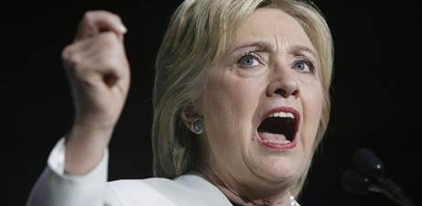

**FACT DC Tweet** 5/10/16 11:45 AM

Read [Here](https://twitter.com/factdc/status/730061091028402176)

.[@HillaryClinton](https://twitter.com/HillaryClinton/) Claims The FBI Hasn’t Asked Her For An Interview Yet: [on.wsj.com/1q9hDhy](https://t.co/DmoJtFm564) via [@WSJ](https://twitter.com/WSJ/)

**Michael C. Short Tweet** 5/10/16 1:33 PM

Read [Here](https://twitter.com/michaelcshort/status/730088176874827776)

CNN: [@HillaryClinton](https://twitter.com/HillaryClinton/) IT staffer's hiring caused confusion among department managers [cnn.it/1T3U4Pq](https://t.co/n6D4TblJ5S)

**Michael C. Short Tweet** 5/10/16 1:42 PM

Read [Here](https://twitter.com/michaelcshort/status/730090290736975872)

Listed on Clinton IT staffer's resume: "Manage discrete projects as required." [cnn.it/1T3U4Pq](https://t.co/n6D4TblJ5S)

**Raj Shah Tweet** 5/10/16 1:45 PM

Read [Here](https://twitter.com/RajShah84/status/730091031350411264)

Pagliano's resume, which is attached ... Among his responsibilities: "Manage discrete projects as required." [cnn.com/2016/05/10/pol…](https://t.co/f3yD90NSzP)

**FACT DC Retweet** 5/10/16 2:36 PM

Read [Here](https://twitter.com/WashTimes/status/730104083374297088)

[**The Washington Times** @WashTimes](https://twitter.com/WashTimes)

Head of D.C. watchdog group calls for special prosecutor in Hillary Clinton email case [bit.ly/24ITLRD](https://t.co/W08a17MIdO)

**Michael C. Short Tweet** 5/10/16 3:02 PM

Read [Here](https://twitter.com/michaelcshort/status/730110668549066752)

WaPo: [@HillaryClinton](https://twitter.com/HillaryClinton/) aide leaves interview briefly when the FBI broaches an off-limits topic [wapo.st/1rRBmnc](https://t.co/iOzPiIQ6qE)

**Michael C. Short Tweet** 5/10/16 3:03 PM

Read [Here](https://twitter.com/michaelcshort/status/730110825483120640)

"...demonstrates some of the tension surrounding the criminal probe into possible mishandling of classified info..." [wapo.st/1qc2dsX](https://t.co/zm0hQLB9y8)

**FACT DC Tweet** 5/10/16 3:05 PM

Read [Here](https://twitter.com/factdc/status/730111444755193856)

BREAKING: "State Department claims it can't find any [@HillaryClinton](https://twitter.com/HillaryClinton/) texts or email file for IT aide" [politi.co/1rQwNcO](https://t.co/fu3FfBUooV)

**FACT DC Tweet** 5/10/16 4:02 PM

Read [Here](https://twitter.com/factdc/status/730125567094194176)

.[@factdc](https://twitter.com/factdc/) Executive Director Interviewed By [@SimonRadio1776](https://twitter.com/SimonRadio1776/) About Latest [@HillaryClinton](https://twitter.com/HillaryClinton/) Email Scandal News [youtube.com/watch?v=rqdDQK…](https://t.co/iJGhsgR0Tc)

**FACT DC Tweet** 5/10/16 5:36 PM

Read [Here](https://twitter.com/factdc/status/730149177435422720)

.[@FoxNews](https://twitter.com/FoxNews/): "AG Lynch says she cannot make 'prediction' about timing of [@HillaryClinton](https://twitter.com/HillaryClinton/) probe" [fxn.ws/1T94bou](https://t.co/Fty4frCPqS)

**RNC Tweet** 5/10/16 6:05 PM

Read [Here](https://twitter.com/GOP/status/730156464061321219)

ICYMI: State Dept admitted it didn't possess any emails from Clinton's IT staffer from the time she served as SoS [apne.ws/21Pjiqn](https://t.co/MkD8cb1Gp0)

**Michael C. Short Tweet** 5/10/16 10:01 AM

Read [Here](https://twitter.com/michaelcshort/status/730216120377065472)

Fmr. DOJ FOIA Director on [@HillaryClinton](https://twitter.com/HillaryClinton/) Aide’s Missing Emails: ‘It Stinks to High Heaven’ [bit.ly/1ZD91Mh](https://t.co/vqEEXZlWS8)

**RNC Research Tweet** 5/11/16 8:33 AM

Read [Here](https://twitter.com/RNCResearch/status/730375175955451904)

VIDEO: Fmr Clinton Aide Blumenthal Dodges On Why Clinton Used Private Server [youtu.be/ZeKaSwCSMDQ](https://t.co/AvyeUzorSC)

**Raj Shah Tweet** 5/11/16 8:45 AM

Read [Here](https://twitter.com/RajShah84/status/730378000705982464)

VIDEO: Fmr Clinton Aide Blumenthal Dodges On Why Clinton Used Private Server [youtu.be/ZeKaSwCSMDQ](https://t.co/MXwrfszTZi)

**RNC Tweet** 5/11/16 9:53 AM

Read [Here](https://twitter.com/GOP/status/730395299617759232)

Fmr dir of Justice Dept’s FOIA office says ex-Hillary Clinton IT staffer's “missing” emails “stinks to high heaven.” [gop.cm/D7GPhV](https://t.co/8ibVMDziRx)

**RNC Research Tweet** 5/11/16 10:03 AM

Read [Here](https://twitter.com/RNCResearch/status/730398063118946304)

VIDEO: MSNBC Panel Pans State Department Over "Lost" Pagliano Emails [youtu.be/Vy3KXXUz5vg](https://t.co/rd4lxeD5am)

**Raj Shah Tweet** 5/11/16 10:05 AM

Read [Here](https://twitter.com/RajShah84/status/730398068277907456)

VIDEO: MSNBC Panel Pans State Department Over "Lost" Pagliano Emails [youtu.be/Vy3KXXUz5vg](https://t.co/01mCqDK8ub)

**FACT DC Tweet** 5/11/16 11:01 AM

Read [Here](https://twitter.com/factdc/status/730412291045265415)

LISTEN: [@factdc](https://twitter.com/factdc/)'s Matt Whitaker Discusses Missing Emails From [@HillaryClinton](https://twitter.com/HillaryClinton/) Aide Who Set Up Email Server on [@KSRO](https://twitter.com/KSRO/) [youtube.com/watch?v=kKeZ4Q…](https://t.co/c1ILVmc0v4)

**America Rising PAC Tweet** 5/11/16 11:34 AM

Read [Here](https://twitter.com/AmericaRising/status/730420709395038209)

How Could This Happen? [@HillaryClinton](https://twitter.com/HillaryClinton/) IT Guy’s State Department Emails Are Still Missing! [amp.twimg.com/v/f4f9e33a-b4a…](https://t.co/EhUk1ScnbV)

**Raj Shah Tweet** 5/11/16 2:02 PM

Read [Here](https://twitter.com/RajShah84/status/730457726871060480)

"It's in our name. I'm not familiar with the term 'security inquiry,' [FBI Director Comey] said." [politico.com/story/2016/05/…](https://t.co/g4QsNUeL1P)

**Raj Shah Tweet** 5/11/16 2:14 PM

Read [Here](https://twitter.com/RajShah84/status/730460955310698497)

The Hill: FBI head challenges Clinton on email probe [bit.ly/1rWCYMq](https://t.co/dKKxsOAs8v)

**Michael C. Short Tweet** 5/11/16 2:16 PM

Read [Here](https://twitter.com/michaelcshort/status/730461390910164995)

The Hill: FBI head challenges [@HillaryClinton](https://twitter.com/HillaryClinton/) on email probe [bit.ly/1rWCYMq](https://t.co/b7eXNjWqTt) via [@jmhattem](https://twitter.com/jmhattem/)

**Michael C. Short Tweet** 5/11/16 4:25 PM

Read [Here](https://twitter.com/michaelcshort/status/730493787148005376)

"...the matter quickly became an investigation into whether anyone had committed a crime..." [twitter.com/nytpolitics/st…](https://t.co/oWvIde3nfa)

[**NYT Politics** @nytpolitics](https://twitter.com/nytpolitics)

The director of the F.B.I. said he would not be rushed into finishing an investigation of Hillary Clinton’s emails [nyti.ms/1TFxpbI](https://t.co/cGuK5YaoJY)

**Michael C. Short Tweet** 5/11/16 6:41 PM

Read [Here](https://twitter.com/michaelcshort/status/730528223801561089)

ABC News: FBI Director Questions [@HillaryClinton](https://twitter.com/HillaryClinton/)'s Description of FBI Email Investigation [abcn.ws/1UTUCMu](https://t.co/FFrJLr1kCC)

**Michael C. Short Tweet** 5/11/16 6:45 PM

Read [Here](https://twitter.com/michaelcshort/status/730529049618059264)

Fox News: Comey rebuffs [@HillaryClinton](https://twitter.com/HillaryClinton/) claim FBI only conducting ‘security inquiry’ on emails [fxn.ws/1X28l40](https://t.co/fffdxCSSPl)

**Michael C. Short Tweet** 5/11/16 7:19 PM

Read [Here](https://twitter.com/michaelcshort/status/730537627028426753)

WSJ: Emails Are Likely to Keep Complicating [@HillaryClinton](https://twitter.com/HillaryClinton/)’s Campaign [on.wsj.com/1seTqZ6](https://t.co/bDv9xKMDAP) via [@ByronTau](https://twitter.com/ByronTau/)

**Michael C. Short Tweet** 5/11/16 10:00 PM

Read [Here](https://twitter.com/michaelcshort/status/730578286405947392)

CBS News: FBI director refutes [@HillaryClinton](https://twitter.com/HillaryClinton/) campaign's description of email investigation [cbsn.ws/1XmbVXb](https://t.co/OfhwxITvUt)

**RNC Research Tweet** 5/11/16 10:16 PM

Read [Here](https://twitter.com/RNCResearch/status/730582384966410240)

5 Times Clinton Looked Into A Camera And Misled About An FBI Investigation [goo.gl/vr8mge](https://t.co/yoEi772fQf)

**Michael C. Short Tweet** 5/12/16 8:22 AM

Read [Here](https://twitter.com/michaelcshort/status/730734960987021313)

New from [@RNCResearch](https://twitter.com/RNCResearch/): 5 Times [@HillaryClinton](https://twitter.com/HillaryClinton/) Looked Into A Camera And Misled About An FBI Investigation [bit.ly/1THjGRM](https://t.co/tfBnhbHObw)

**Michael C. Short Retweet** 5/12/16 8:34 AM

Read [Here](https://twitter.com/jaketapper/status/730738017183408128)

[**Jake Tapper** @jaketapper](https://twitter.com/jaketapper)

Fact Check: Hillary Clinton still spinning emails [@CNNPolitics](https://twitter.com/CNNPolitics/) [cnn.com/videos/politic…](https://t.co/ucHgS9EPxg)

**RNC Tweet** 5/12/16 9:48 AM

Read [Here](https://twitter.com/GOP/status/730756165185900546)

The fallout from Hillary Clinton’s email scandal is likely to complicate her campaign for months [on.wsj.com/1NrAS1b](https://t.co/fzkTv9u7iI)

**RNC Tweet** 5/12/16 11:02 AM

Read [Here](https://twitter.com/GOP/status/730775043135803393)

What's a "security inquiry," [@HillaryClinton](https://twitter.com/HillaryClinton/)? [pic.twitter.com/ogFeZPfBRX](https://t.co/ogFeZPfBRX)

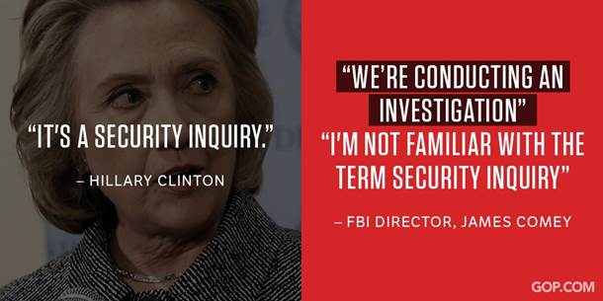

**America Rising PAC Tweet** 5/12/16 11:10 AM

Read [Here](https://twitter.com/AmericaRising/status/730777083538898946)

VIDEO: Another Bad Week Of Headlines For [@HillarClinton](https://twitter.com/HillarClinton/) Thanks To Disgraced Clinton Crony Sidney Blumenthal [bit.ly/1sgVlMO](https://t.co/BRulIDk5V8)

**RNC Tweet** 5/12/16 12:14 PM

Read [Here](https://twitter.com/GOP/status/730792910233305088)

5 times Hillary Clinton looked into a camera and misled about an FBI investigation: [gop.cm/QPQKDZ](https://t.co/tSnSYsMhm3) [pic.twitter.com/X5TFG5Xeqh](https://t.co/X5TFG5Xeqh)

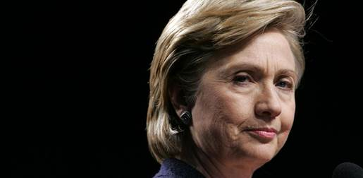

**Raj Shah Retweet** 5/12/16 1:03 PM

Read [Here](https://twitter.com/FrankLuntz/status/730805364116066304)

[**Frank Luntz** @FrankLuntz](https://twitter.com/FrankLuntz)

Looks like FBI Director James Comey just corrected the record. [#DamnEmails](https://twitter.com/search?q=%23DamnEmails) [@CorrectRecord](https://twitter.com/CorrectRecord/) [fxn.ws/1rZssEe](https://t.co/wQNQHwBi35)

**Michael C. Short Tweet** 5/12/16 6:42 PM

Read [Here](https://twitter.com/michaelcshort/status/730890934817161216)

Watchdog: New Emails Show [@HillaryClinton](https://twitter.com/HillaryClinton/) Knew About Security Risks of Private BlackBerry [bit.ly/1VV35Am](https://t.co/QSQqxTfmk2) via [@alanagoodman](https://twitter.com/alanagoodman/)

**RNC Research Tweet** 5/13/16 8:03 AM

Read [Here](https://twitter.com/RNCResearch/status/731092321996029952)

VIDEO: Morning Joe Panel Literally Laughs At Clinton Claim That FBI Investigation Is “Security Inquiry” [youtu.be/Vu1DJ2mMqCU](https://t.co/WEssw01gLn)

**Raj Shah Tweet** 5/13/16 8:38 AM

Read [Here](https://twitter.com/RajShah84/status/731101267947339776)

VIDEO: Morning Joe Panel Literally Laughs At Clinton Claim That FBI Investigation Is “Security Inquiry” [youtu.be/Vu1DJ2mMqCU](https://t.co/GfeuahIQQq)

**America Rising PAC Tweet** 5/13/16 9:13 AM

Read [Here](https://twitter.com/AmericaRising/status/731109896121290752)

VIDEO: Sid "Vicious" Blumenthal Didn’t Give The Suspect Nature Of [@HillaryClinton](https://twitter.com/HillaryClinton/)’s Private Server “Any Thought" [amp.twimg.com/v/e1d6cd01-f7c…](https://t.co/FYYGvYzgu2)

**Raj Shah Retweet** 5/13/16 9:37 AM

Read [Here](https://twitter.com/thehill/status/731116034535608320)

[**The Hill** @thehill](https://twitter.com/thehill)

Newly released email shows Clinton abandoned secure line to use home phone: [hill.cm/bUtQP72](https://t.co/967828Vlvw) [pic.twitter.com/gu6mxG67BA](https://t.co/gu6mxG67BA)

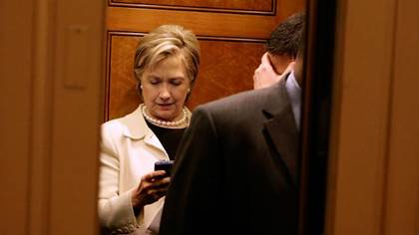

**Raj Shah Tweet** 5/13/16 10:13 AM

Read [Here](https://twitter.com/RajShah84/status/731125143569891332)

VIDEO: DWS Struggles To Explain Clinton’s Mischaracterization Of The FBI’s Investigation Into Her Email Use [youtu.be/4sSMRg4idEY](https://t.co/MqZQe2t3aM)

**RNC Research Tweet** 5/13/16 10:14 AM

Read [Here](https://twitter.com/RNCResearch/status/731125325413810176)

VIDEO: DWS Struggles To Explain Clinton’s Mischaracterization Of The FBI’s Investigation Into Her Email Use [youtu.be/4sSMRg4idEY](https://t.co/nppKI8XwlG)

**RNC Tweet** 5/13/16 11:42 AM

Read [Here](https://twitter.com/GOP/status/731147494269190144)

New emails show Hillary Clinton throwing security to the wind & discussing sensitive matters over unsecure means [gop.cm/sbYxBK](https://t.co/vjqHdjHsrp)

**FACT DC Tweet** 5/13/16 12:30 PM

Read [Here](https://twitter.com/factdc/status/731159689057079296)

.[@factdc](https://twitter.com/factdc/)'s Matt Whitaker On [@LarsLarsonShow](https://twitter.com/LarsLarsonShow/) Discusses Security Implications Of [@HillaryClinton](https://twitter.com/HillaryClinton/)'s Unsecured Server [youtu.be/EVRQrTua8tI](https://t.co/XA6WsD9GtG)

**RNC Tweet** 5/13/16 1:52 PM

Read [Here](https://twitter.com/GOP/status/731180235442413568)

Calling it a "security inquiry" over and over doesn't make it true, [@HillaryClinton](https://twitter.com/HillaryClinton/). [amp.twimg.com/v/bca2a791-f12…](https://t.co/kSlaKQEQ8Q)

**Sean Spicer Tweet** 5/13/16 2:44 PM

Read [Here](https://twitter.com/seanspicer/status/731193138375725056)

These are not the drones you are looking for: DNC Chair [@DWStweets](https://twitter.com/DWStweets/) claims [@HillaryClinton](https://twitter.com/HillaryClinton/) not target’ of FBI probe [foxnews.com/politics/2016/…](https://t.co/UlEqLrEVFc)

**FACT DC Tweet** 5/13/16 3:30 PM

Read [Here](https://twitter.com/factdc/status/731204922285260800)

On Talk Back w/Chuck Wilder, [@factdc](https://twitter.com/factdc/)'s Exec Dir Talks [@HillaryClinton](https://twitter.com/HillaryClinton/)'s Private Server Scandal cc: [@CRNDigitalTalk](https://twitter.com/CRNDigitalTalk/) [youtube.com/watch?v=HGwXQH…](https://t.co/67pcE0gvUT)

BACK TO TOP ↑

## Campaign

|  |  |
| --- | --- |
| https://pbs.twimg.com/profile_images/598572897045622784/1SirVngg_normal.jpg | **GOP (**[**@GOP**](https://twitter.com/gop?refsrc=email&s=11)**)** |
| [5/7/16, 10:49 AM](https://twitter.com/gop/status/728959834247168000?refsrc=email&s=11)  Bill and Hillary Clinton will say and do anything to win. Keep these two out in November: [gop.cm/DzV8LF](https://t.co/WbRoPXWzdi) [pic.twitter.com/LcqeESFfle](https://t.co/LcqeESFfle) | |

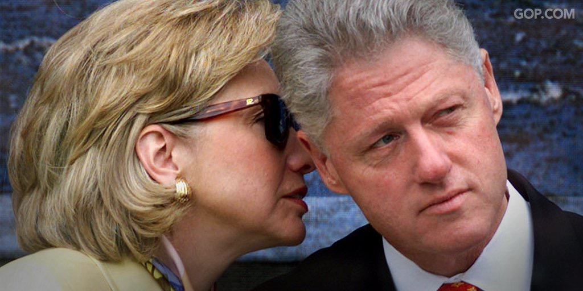

**RNC Research Tweet** 5/9/16 10:12 AM

Read [Here](https://twitter.com/RNCResearch/status/729675361982754816)

VIDEO: MSNBC’s Kornacki On Dem Primary: Still Some States Clinton Could Be In Trouble In [youtu.be/xfESc4pEMUs](https://t.co/YIjRZXqurj)

**Michael C. Short Tweet** 5/9/16 10:34 AM

Read [Here](https://twitter.com/michaelcshort/status/729680550043238400)

It's May, folks, and [@HillaryClinton](https://twitter.com/HillaryClinton/) could lose even more states ... [twitter.com/RNCResearch/st…](https://t.co/Se6vLztzS5)

[**RNC Research** @RNCResearch](https://twitter.com/RNCResearch)

VIDEO: MSNBC’s Kornacki On Dem Primary: Still Some States Clinton Could Be In Trouble In [youtu.be/xfESc4pEMUs](https://t.co/YIjRZXqurj)

**Donald Trump Tweet** 5/9/16 12:57 PM

Read [Here](https://twitter.com/realDonaldTrump/status/729716712124362754)

Crooked Hillary Clinton says that she got more primary votes than Donald Trump. But I had 17 people to beat—she had one!

**Donald Trump Tweet** 5/9/16 12:58 PM

Read [Here](https://twitter.com/realDonaldTrump/status/729717006749052928)

If I only had 1 person running against me in the primaries like Hillary Clinton, I would have gotten 10 million more votes than she did!

**RNC Tweet** 5/9/16 5:51 PM

Read [Here](https://twitter.com/GOP/status/729791060021415936)

We can't let another Clinton in the White House in November. [#StopHillary](https://twitter.com/search?q=%23StopHillary) [pic.twitter.com/IMNusfKFVk](https://t.co/IMNusfKFVk)

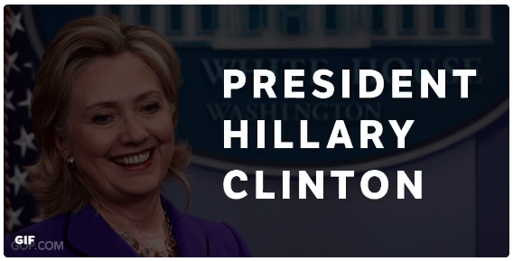

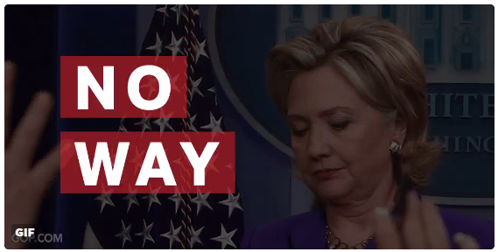

|  |  |
| --- | --- |
| https://pbs.twimg.com/profile_images/647426759651033088/lQLvX5XF_normal.png | **Sean Spicer (**[**@seanspicer**](https://twitter.com/seanspicer?refsrc=email&s=11)**)** |
| [5/10/16, 7:03 AM](https://twitter.com/seanspicer/status/729990348248887296?refsrc=email&s=11)  .[@HillaryClinton](https://twitter.com/HillaryClinton) National Lead Over Bernie Sanders Shrinks Via [@NBCNews](https://twitter.com/NBCNews)  [nbcnews.com/politics/2016-…](https://t.co/paXN3W2WOT) | |

**RNC Research Tweet** 5/10/16 9:44 AM

Read [Here](https://twitter.com/RNCResearch/status/730030534051680260)

VIDEO: MSNBC’s Geist: “There Are Some Signs Of Pressure” For Clinton As She Resumes Ad Buys Against Sanders [youtu.be/0MXFbfZRgCM](https://t.co/AoGP4zO7Ze)

**Raj Shah Tweet** 5/10/16 9:51 AM

Read [Here](https://twitter.com/RajShah84/status/730032436537634816)

VIDEO: MSNBC’s Geist: “There Are Some Signs Of Pressure” For Clinton As She Resumes Ad Buys Against Sanders [youtu.be/0MXFbfZRgCM](https://t.co/25oHvYUxIP)

**America Rising PAC Tweet** 5/10/16 11:31 AM

Read [Here](https://twitter.com/AmericaRising/status/730057435340099584)

.[@HillaryClinton](https://twitter.com/HillaryClinton/) Is Headed For Another Loss & Is Facing A Troubling Lack Of Democratic Unity Around Her Candidacy—> [bit.ly/1rEsXDM](https://t.co/J6JFY9kFvq)

**Michael C. Short Tweet** 5/10/16 12:32 PM

Read [Here](https://twitter.com/michaelcshort/status/730072833368461312)

That's one way to put it ... [twitter.com/llerer/status/…](https://t.co/NtJS5R6RCM)

[**Lisa Lerer** @llerer](https://twitter.com/llerer)

Fun [@amychozick](https://twitter.com/amychozick/) read on an unusual Clinton pet cause: UFOs. [ow.ly/9hP630053vG](https://t.co/CeJNUH2Q4e)

**America Rising PAC Tweet** 5/10/16 5:00 PM

Read [Here](https://twitter.com/AmericaRising/status/730140439177617408)

Heckled By Voters, Protested At Campaign Stops, and Loss In Indiana: [@HillaryClinton](https://twitter.com/HillaryClinton/)’s Disappointing Campaign Month [bit.ly/1rEsXDM](https://t.co/J6JFY9kFvq)

**Sean Spicer Tweet** 5/10/16 7:46 PM

Read [Here](https://twitter.com/seanspicer/status/730181972442550272)

in 2008 [#WestVirginiaPrimary](https://twitter.com/search?q=%23WestVirginiaPrimary) [@HillaryClinton](https://twitter.com/HillaryClinton/) crushed Obama 67-27 -- fast forward to 2016 she is about to lose to a 74 year old socialist

**Sean Spicer Tweet** 5/10/16 7:49 PM

Read [Here](https://twitter.com/seanspicer/status/730182689563676673)

the reality is tonight really isnt about [@BernieSanders](https://twitter.com/BernieSanders/) winning [#WestVirginiaPrimary](https://twitter.com/search?q=%23WestVirginiaPrimary) as much as [@HillaryClinton](https://twitter.com/HillaryClinton/) losing it

**Michael C. Short Tweet** 5/10/16 9:26 PM

Read [Here](https://twitter.com/michaelcshort/status/730207201726500865)

Clinton has now lost 20 states (and counting) to THIS guy --> [twitter.com/AP_Politics/st…](https://t.co/IXk1tb27LH)

[**AP Politics** @AP_Politics](https://twitter.com/AP_Politics)

BREAKING: Bernie Sanders wins the Democratic [#WVPrimary](https://twitter.com/search?q=%23WVPrimary). [@AP](https://twitter.com/AP/) race call at 9:24 p.m. EDT. [#Election2016](https://twitter.com/search?q=%23Election2016) [#APracecall](https://twitter.com/search?q=%23APracecall) [pic.twitter.com/05JSggz0bU](https://t.co/05JSggz0bU)

**Reince Priebus Tweet** 5/10/16 9:29 PM

Read [Here](https://twitter.com/Reince/status/730207741466140673)

It is nothing short of embarrassing that Hillary Clinton has now been defeated twenty times by a 74-year old socialist from Vermont

**Sean Spicer Tweet** 5/10/16 9:57 PM

Read [Here](https://twitter.com/seanspicer/status/730215008370483200)

.[@GOP](https://twitter.com/GOP/) Statement On Hillary Clinton’s 20th Loss To Bernie Sanders: [bit.ly/1qcCXmz](https://t.co/dOohV4AOjg)

[**RNC Statement On Hillary Clinton's 20th Loss To Bernie Sanders**](https://gop.com/rnc-statement-on-hillary-clintons-20th-loss-to-bernie-sanders/)

[**ELECTION 2016**](https://gop.com/topic/elections-election-2016/)- May 10, 2016

**WASHINGTON**– Republican National Committee (RNC) Chairman Reince Priebus released the following statement on Hillary Clinton’s defeat in the West Virginia primary and her twentieth loss to Bernie Sanders:                         
“It is nothing short of embarrassing that Hillary Clinton has now been defeated twenty times by a 74-year old socialist from Vermont, and for the second straight week lost a state she carried in 2008. Setbacks this late into the primary calendar show her long track record of dishonesty and hypocrisy continues to alienate large swathes of Democrat voters. Whether it’s her vows to decimate the coal industry, the FBI’s investigation into her reckless conduct as secretary of state, or her support for a left-wing majority on the Supreme Court, Hillary Clinton has shown she is incapable of delivering the leadership our country desperately needs.”

###

**Donald Trump Tweet** 5/11/16 6:22 AM

Read [Here](https://twitter.com/realDonaldTrump/status/730342411835195393)

Big wins in West Virginia and Nebraska. Get ready for November - Crooked Hillary, who is looking very bad against Crazy Bernie, will lose!

**Donald Trump Tweet** 5/10/16 6:26 AM

Read [Here](https://twitter.com/realDonaldTrump/status/730343346204508160)

I don't want to hit Crazy Bernie Sanders too hard yet because I love watching what he is doing to Crooked Hillary. His time will come!

**Michael C. Short Tweet** 5/11/16 8:02 AM

Read [Here](https://twitter.com/michaelcshort/status/730367250113298433)

Politico: [@HillaryClinton](https://twitter.com/HillaryClinton/)'s primary quagmire [politi.co/1rUV1CS](https://t.co/wrjymwEuWh)

**Michael C. Short Tweet** 5/11/16 9:47 AM

Read [Here](https://twitter.com/michaelcshort/status/730394010108432384)

"Dems are now growing uneasy over a rocky finish that has Clinton spending resources & political capital so late..." [politi.co/1rUV1CS](https://t.co/wrjymwW6kR)

**Michael C. Short Tweet** 5/11/16 10:02 AM

Read [Here](https://twitter.com/michaelcshort/status/730397562486849536)

ABC News: Democrats Again Sound Alarms for [@HillaryClinton](https://twitter.com/HillaryClinton/) [abcn.ws/1TQrh35](https://t.co/mnIFtes71E) via [@rickklein](https://twitter.com/rickklein/)

**Raj Shah Tweet** 5/11/16 10:07 AM

Read [Here](https://twitter.com/RajShah84/status/730398855490088961)

ABC News: ANALYSIS: Democrats Again Sound Alarms for Hillary Clinton [abcnews.go.com/Politics/analy…](https://t.co/w4Alwp2ZqY)

**Raj Shah Tweet** 5/11/16 10:09 AM

Read [Here](https://twitter.com/RajShah84/status/730399086973730816)

D's "repeated the message ... They’re not ready to fall in line for Clinton." [abcnews.go.com/Politics/analy…](https://t.co/w4Alwp2ZqY)

**Michael C. Short Tweet** 5/11/16 10:14 AM

Read [Here](https://twitter.com/michaelcshort/status/730400636764860416)

ABC: "Clinton’s struggles among core Democrats continue ... Concerns about Clinton’s honesty and trustworthiness continue to haunt her ..."

**America Rising PAC Tweet** 5/11/16 10:36 AM

Read [Here](https://twitter.com/AmericaRising/status/730406288493023233)

The Top 5 Numbers To Know From The [#WVPrimary](https://twitter.com/search?q=%23WVPrimary) & [@HillaryClinton](https://twitter.com/HillaryClinton/)’s Devastating Collapse: [bit.ly/1sdmSyV](https://t.co/E35taobvec) [pic.twitter.com/s04TowJitn](https://t.co/s04TowJitn)

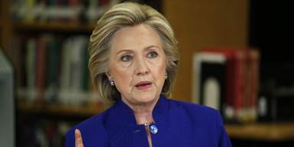

**Raj Shah Tweet** 5/11/16 11:27 AM

Read [Here](https://twitter.com/RajShah84/status/730418830237896704)

Reuters: Exclusive: Trump surges in support, almost even with Clinton in national U.S. poll [reuters.com/article/us-usa…](https://t.co/dE1H7u0uwX)

**RNC Research Tweet** 5/11/16 12:02 PM

Read [Here](https://twitter.com/RNCResearch/status/730427493971267584)

Clinton’s West Virginia Collapse [gop.com/clintons-west-…](https://t.co/jt20vEwZLK)

**RNC Tweet** 5/11/16 12:17 PM

Read [Here](https://twitter.com/GOP/status/730431694184931330)

Hillary Clinton's WV collapse will force a prolonged "costly and distracting" primary fight: [gop.cm/EfCLff](https://t.co/yOIIzGLOfp) [pic.twitter.com/FHE2hnr3bX](https://t.co/FHE2hnr3bX)

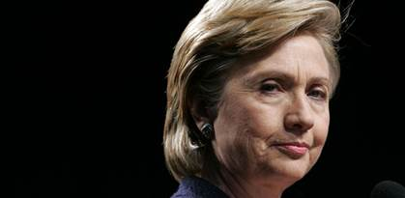

**RNC Research Tweet** 5/11/16 1:39 PM

Read [Here](https://twitter.com/RNCResearch/status/730452065722454016)

VIDEO: Clinton Laughs As Person Introducing Her Takes “Under God” Out Of Pledge [youtube.com/watch?v=bB3QVQ…](https://t.co/ZF5Nrtb8xG)

**Michael C. Short Tweet** 5/11/16 1:42 PM

Read [Here](https://twitter.com/michaelcshort/status/730452836467773445)

VIDEO: [@HillaryClinton](https://twitter.com/HillaryClinton/) Laughs As Person Introducing Her Takes “Under God” Out Of Pledge [bit.ly/1Ymasi0](https://t.co/mU8vGTJEbg)

**Raj Shah Tweet** 5/11/16 2:15 PM

Read [Here](https://twitter.com/RajShah84/status/730460670601400322)

RT [@FreeBeacon](https://twitter.com/FreeBeacon/): Woman Takes “Under God” Out Of Pledge, Watch [@HillaryClinton](https://twitter.com/HillaryClinton/)’s Response [goo.gl/XmYl1c](https://t.co/qFzkFlmc0X) [pic.twitter.com/XvyKscDoIj](https://t.co/XvyKscDoIj)

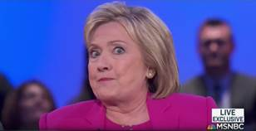

**America Rising PAC Tweet** 5/11/16 4:30 PM

Read [Here](https://twitter.com/AmericaRising/status/730495449342218241)

What A Difference 8 Years Makes For [@HillaryClinton](https://twitter.com/HillaryClinton/). How Far Did Her [#WVPrimary](https://twitter.com/search?q=%23WVPrimary) Numbers Fall In Just 8 Years? [bit.ly/1sdmSyV](https://t.co/E35taot65K)

**Sean Spicer Tweet** 5/12/16 8:32 AM

Read [Here](https://twitter.com/seanspicer/status/730737369280745472)

.[@HillaryClinton](https://twitter.com/HillaryClinton/) surrogate leaves out ‘Under God’ during Hillary Clinton campaign stop in NJ [nj1015.com/freeholder-lea…](https://t.co/eRxb0D5KdZ)

**America Rising PAC Tweet** 5/12/16 9:41 AM

Read [Here](https://twitter.com/AmericaRising/status/730754774723887106)

.[@elizabethforma](https://twitter.com/elizabethforma/) Predicted That [@HillaryClinton](https://twitter.com/HillaryClinton/) Would Face A “Progressive Backlash.” Read More HERE—> [bit.ly/1rHMLGj](https://t.co/cD16sqMIp4)

**America Rising PAC Tweet** 5/12/16 4:00 PM

Read [Here](https://twitter.com/AmericaRising/status/730850120565039108)

.[@elizabethforma](https://twitter.com/elizabethforma/)’s Predictions About [@HillaryClinton](https://twitter.com/HillaryClinton/)’s Candidacy Are Coming True! [bit.ly/1rHMLGj](https://t.co/cD16sr4jgC)

**America Rising PAC Tweet** 5/13/16 11:16 AM

Read [Here](https://twitter.com/AmericaRising/status/731140746854567937)

.[@HillaryClinton](https://twitter.com/HillaryClinton/) Receives Another Backhanded Endorsement, This Time From The [@latimes](https://twitter.com/latimes/) [bit.ly/1TaKtvF](https://t.co/OUfloAZXSi) [pic.twitter.com/s9QDzNM34v](https://t.co/s9QDzNM34v)

More Britney GIFs:

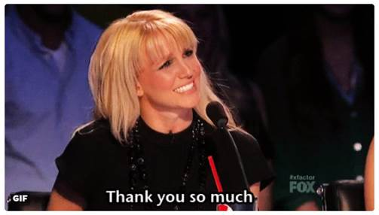

BACK TO TOP ↑

## Scandals

**NRSC Tweet** 5/13/16 9:25 AM

Read [Here](https://twitter.com/NRSC/status/731112818129403904)

Hillary Clinton's toxic campaign will seep into Senate Dems' campaigns. [bit.ly/1ZMEHz0](https://t.co/u78QZXXuqF) [#MOSen](https://twitter.com/search?q=%23MOSen) [#NVSen](https://twitter.com/search?q=%23NVSen) [#PASen](https://twitter.com/search?q=%23PASen) [pic.twitter.com/YTE7osTcLg](https://t.co/YTE7osTcLg)

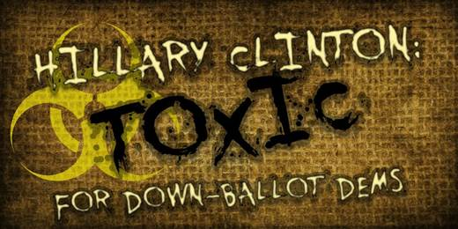

**Raj Shah Retweet** 5/13/16 10:20 AM

Read [Here](https://twitter.com/iprior1177/status/731126762021720065)

[**Ian Prior** @iprior1177](https://twitter.com/iprior1177)

Damn, the [@NRSC](https://twitter.com/NRSC/) just crushes it with this anti- [@HillaryClinton](https://twitter.com/HillaryClinton/) ad. [youtube.com/watch?v=UWXNpr…](https://t.co/kkZ4KlslUF) [#NeverHillary](https://twitter.com/search?q=%23NeverHillary) [#CrookedHillary](https://twitter.com/search?q=%23CrookedHillary)

**“Toxic”**

**Video**: “Democrat senate candidates need to ask themselves a question: can they really support Hillary Clinton? She’s a living history… of scandal, lies, and spin. Defended an accused child rapist, then laughed about his lenient sentence. Whitewater. Travelgate. Chinagate. Filegate. She politically attacked sexual harassment victims, pretended she landed under sniper fire. Benghazi. The Clinton Foundation. FBI Investigation. ‘Ruthless’ (supposedly quoting Washington Post). Fake accents (sounds of her laughing). Fake concerns. And fake laughs. Hillary Clinton. She’s the living embodiment of everything people hate about politics. Democrat senate candidates, she is your burden to bear. [HRC laughing, saying “I am a real person!”]”

**NRSC Retweeted** 5/13/16 10:07 AM

Read [Here](https://twitter.com/Naseeoh/status/731123712087330816)

[**Michael Marinaccio** @Naseeoh](https://twitter.com/Naseeoh)

.[@NRSC](https://twitter.com/NRSC/) like, "Hillary Clinton, don't you know that you're toxic?" [youtu.be/UWXNprUYF7I](https://t.co/QZuBcYoYlb) [pic.twitter.com/oqtgy8gw0d](https://t.co/oqtgy8gw0d)

GIF of Britney in the iconic ‘Toxic’ video:

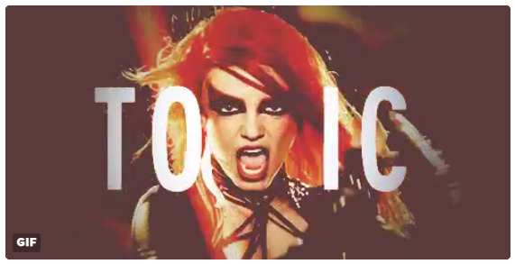

**America Rising PAC Tweet** 5/13/16 10:42 AM

Read [Here](https://twitter.com/AmericaRising/status/731132460344320000)

.[@AmericaRising](https://twitter.com/AmericaRising/)'s Newest Video Shows A Terrifying Glimpse Of "President Hillary Clinton" [bit.ly/1Wv7o5c](https://t.co/L8wMfguW7D) [amp.twimg.com/v/aa5193d3-e73…](https://t.co/6nguXWRHIY)

**NRSC Tweet**

5/13/16 11:36 AM

Read [Here](https://twitter.com/NRSC/status/731146111898025984)

Hillary Clinton's first toxic scandal was underway before Britney Spears was even born. [bit.ly/1ZMEHz0](https://t.co/u78QZXXuqF) [pic.twitter.com/WRfLlbwjhK](https://t.co/WRfLlbwjhK)

More Britney Toxic GIFs:

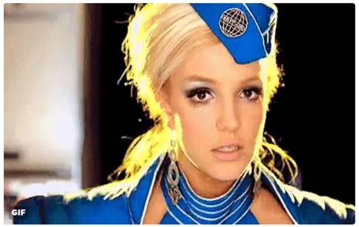

**NRSC Tweet** 5/13/16 11:38 AM

Read [Here](https://twitter.com/NRSC/status/731146501636919300)

Here are Hillary's scandals Dems will have to answer for (you may've forgotten a few): [bit.ly/1ZMEHz0](https://t.co/u78QZXXuqF) [pic.twitter.com/sNeqV3lXS7](https://t.co/sNeqV3lXS7)

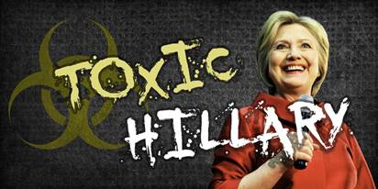

**NRSC Retweet** 5/13/16 12:52 PM

Read [Here](https://twitter.com/WardBaker/status/731164868234104834)

[**Ward Baker** @WardBaker](https://twitter.com/WardBaker)

Hillary Clinton is TOXIC: Benghazi, Filegate, FBI Investigation, Chinagate, Travelgate, Clinton Foundation. [amp.twimg.com/v/4abc2c2e-cba…](https://t.co/OvtVAGV1iV)

**Michael C. Short Tweet** 5/13/16 3:25 PM

Read [Here](https://twitter.com/michaelcshort/status/731203741320253440)

Fox News: Flight logs show Bill Clinton flew on sex offender's jet much more than previously known [fxn.ws/1TaZ8ac](https://t.co/2e2BFa5C1r)

**Raj Shah Tweet** 5/13/16 3:28 PM

Read [Here](https://twitter.com/RajShah84/status/731204366988914688)

BREAKING: Fox News: Flight logs show [@billclinton](https://twitter.com/billclinton/) flew on sex offender's jet much more than previously known [foxnews.com/us/2016/05/13/…](https://t.co/eKKqi9MzBS)

BACK TO TOP ↑

## Trump’s the Best at Beating Hillary!

**Eric Trump Retweet** 5/5/16 6:16 PM

Read [Here](https://twitter.com/RealKevinNash/status/728347671140966401)

[**Kevin Nash** @RealKevinNash](https://twitter.com/RealKevinNash)

Sported this shirt all day to see the responses I'd get . Hilary you're in trouble girl [pic.twitter.com/0dDW37paI2](https://t.co/0dDW37paI2)

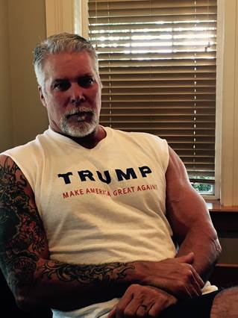

|  |  |
| --- | --- |
| https://pbs.twimg.com/profile_images/1980294624/DJT_Headshot_V2_normal.jpg | **Donald J. Trump (**[**@realDonaldTrump**](https://twitter.com/realdonaldtrump?refsrc=email&s=11)**)** |
| [5/9/16, 5:32 AM](https://twitter.com/realdonaldtrump/status/729604845716516864?refsrc=email&s=11)  I will win the election against Crooked Hillary despite the people in the Republican Party that are currently and selfishly opposed to me! | |

**Dan Scavino Tweet** 5/10/16 10:56 AM

Read [Here](https://twitter.com/DanScavino/status/730048583739817987)

FLORIDA POLLING DONALD J. TRUMP VS. CROOKED HILLARY CLINTON [pic.twitter.com/jSBzx4iyPJ](https://t.co/jSBzx4iyPJ)

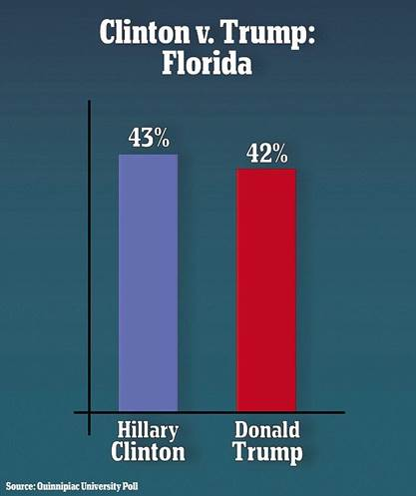

**Dan Scavino Tweet** 5/10/16 10:56 AM

Read [Here](https://twitter.com/DanScavino/status/730048796219068416)

PENNSYLVANIA POLLING DONALD J. TRUMP VS. CROOKED HILLARY CLINTON [pic.twitter.com/sYUTPWLf4A](https://t.co/sYUTPWLf4A)

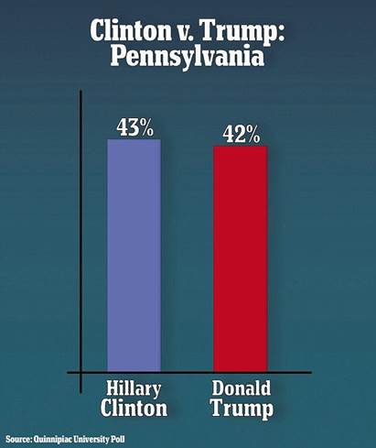

**Dan Scavino Tweet** 5/10/16 10:58 AM

Read [Here](https://twitter.com/DanScavino/status/730049407853416448)

Swing States Polling Florida, Ohio, Pennsylvania [#Trump2016](https://twitter.com/search?q=%23Trump2016) VS. [#CrookedHillary](https://twitter.com/search?q=%23CrookedHillary) [pic.twitter.com/i8TWTuAQ5X](https://t.co/i8TWTuAQ5X)

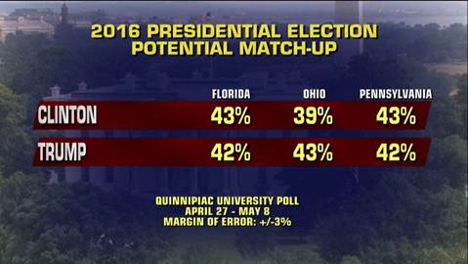

**America Rising PAC Tweet** 5/10/16 11:01 AM

Read [Here](https://twitter.com/AmericaRising/status/730049988391108608)

What Happened To [@HillaryClinton](https://twitter.com/HillaryClinton/)? Q-Poll Swing State Edition: [bit.ly/1T1yf6B](https://t.co/0IZWsmWVHt) [pic.twitter.com/ZMLBQ9TSAw](https://t.co/ZMLBQ9TSAw)

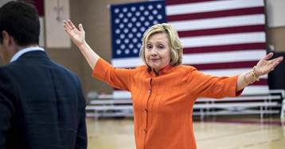

**Dan Scavino Tweet** 5/10/16 2:12 PM

Read [Here](https://twitter.com/DanScavino/status/730097845739655172)

THANK YOU‼️

✅FLORIDA🚂🇺🇸🇺🇸

✅OHIO🚂🇺🇸🇺🇸

✅PENNSYLVANIA🚂🇺🇸🇺🇸

[@realDonaldTrump](https://twitter.com/realDonaldTrump/) will NOT let you down as our 45th [#POTUS](https://twitter.com/search?q=%23POTUS) [pic.twitter.com/JRlYBnXIC7](https://t.co/JRlYBnXIC7)

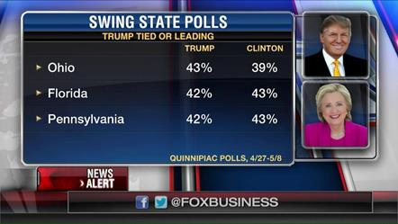

**NRSC Tweet** 5/10/16 3:11 PM

Read [Here](https://twitter.com/NRSC/status/730112978926882816)

POLLING UPDATE: Hillary isn't doing any favors for swing-state Dems. [#PASen](https://twitter.com/search?q=%23PASen) [#OHSen](https://twitter.com/search?q=%23OHSen) [#FLSen](https://twitter.com/search?q=%23FLSen) [politico.com/story/2016/05/…](https://t.co/ggSmMjDoHC) [pic.twitter.com/7sM5ih3Ejy](https://t.co/7sM5ih3Ejy)

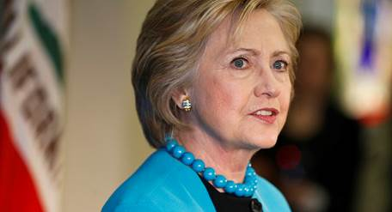

**Dan Scavino Tweet** 5/10/16 3:16 PM

Read [Here](https://twitter.com/DanScavino/status/730114222739296257)

LOUISIANA GENERAL ELECTION Donald Trump vs. Hillary Clinton [#MakeAmericaGreatAgain](https://twitter.com/search?q=%23MakeAmericaGreatAgain) [#Trump2016](https://twitter.com/search?q=%23Trump2016) [pic.twitter.com/74vYOx7dKz](https://t.co/74vYOx7dKz)

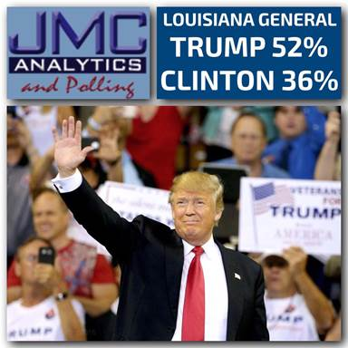

**Dan Scavino Tweet** 5/10/16 4:05 PM

Read [Here](https://twitter.com/DanScavino/status/730126518928740353)

OHIO GENERAL ELECTION Donald Trump vs. Hillary Clinton [#MakeAmericaGreatAgain](https://twitter.com/search?q=%23MakeAmericaGreatAgain) [#Trump2016](https://twitter.com/search?q=%23Trump2016) [pic.twitter.com/0yXQ4SFSLO](https://t.co/0yXQ4SFSLO)

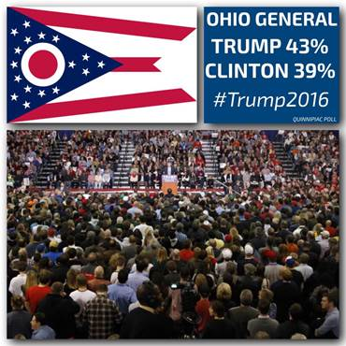

**Barry Bennett Tweet** 5/10/16 6:00 PM

Read [Here](https://twitter.com/BBennett152/status/730155117530492928)

Tied in Pennsylvania and Florida and winning in Ohio. Where's the Clinton blowout? Averaging 6 points better than Romney at this stage.

**Raj Shah Tweet** 5/11/16 11:27 AM

Read [Here](https://twitter.com/RajShah84/status/730418830237896704)

Reuters: Exclusive: Trump surges in support, almost even with Clinton in national U.S. poll [reuters.com/article/us-usa…](https://t.co/dE1H7u0uwX)

**Donald Trump Tweet** 5/11/16 1:44 PM

Read [Here](https://twitter.com/realDonaldTrump/status/730453302287142913)

[#MakeAmericaGreatAgain](https://twitter.com/search?q=%23MakeAmericaGreatAgain) [#Trump2016](https://twitter.com/search?q=%23Trump2016) [pic.twitter.com/CLhqgybbYR](https://t.co/CLhqgybbYR)

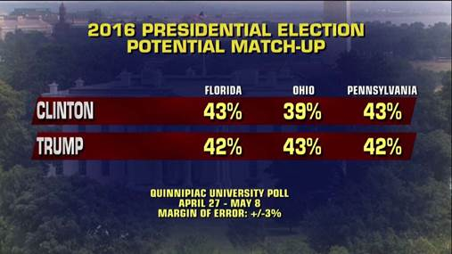

**Barry Bennett Tweet** 5/11/16 1:45 PM

Read [Here](https://twitter.com/BBennett152/status/730453508558852096)

Exclusive: Trump surges in support, almost even with Clinton in national U.S. poll [reut.rs/1OnC00R](https://t.co/PzM88Nw2oG) via [@Reuters](https://twitter.com/Reuters/)

**Donald Trump Tweet** 5/11/16 3:09 PM

Read [Here](https://twitter.com/realDonaldTrump/status/730474838012366849)

Thanks Piers. [twitter.com/piersmorgan/st…](https://t.co/hiDDT9hV0j)

[**Piers Morgan** @piersmorgan](https://twitter.com/piersmorgan)

Trump surging in national polls incl crucial swing states. He's coming for you Hillary... start panicking! [@realDonaldTrump](https://twitter.com/realDonaldTrump/)

**Paul Ryan Tweet** 5/12/16 11:15 AM

Read [Here](https://twitter.com/PRyan/status/730778247718440960)

[pic.twitter.com/Fyt9VkdCFv](https://t.co/Fyt9VkdCFv)

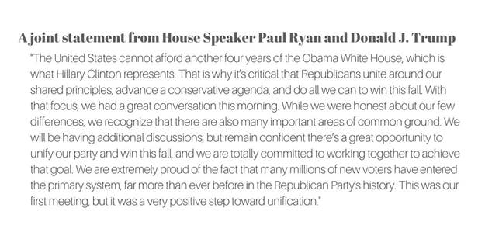

BACK TO TOP ↑

## Money, Friends, and Donors

**America Rising PAC Tweet** 5/9/16 10:20 AM

Read [Here](https://twitter.com/AmericaRising/status/729677535425003520)

A Bad Weekend For Surrogates: [@HillaryClinton](https://twitter.com/HillaryClinton/) Surrogate Barney Frank Had A Dreadful Weekend [bit.ly/277xKxW](https://t.co/NFp6Nhh0G3) [pic.twitter.com/1LhbXKLcV0](https://t.co/1LhbXKLcV0)

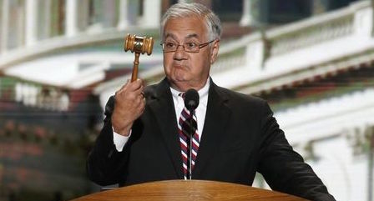

**America Rising PAC Tweet** 5/9/16 3:17 PM

Read [Here](https://twitter.com/AmericaRising/status/729752075240800256)

Get Used To It America: Top Surrogate Ed Rendell Says [@HillaryClinton](https://twitter.com/HillaryClinton/)'s Moves To The Left Are Here To Stay [bit.ly/1s8bh49](https://t.co/49gllVJJRj)

|  |  |
| --- | --- |
| https://pbs.twimg.com/profile_images/647426759651033088/lQLvX5XF_normal.png | **Sean Spicer (**[**@seanspicer**](https://twitter.com/seanspicer?refsrc=email&s=11)**)** |
| [5/10/16, 7:06 AM](https://twitter.com/seanspicer/status/729990960902451200?refsrc=email&s=11)  Talk about working the refs: [@HillaryClinton](https://twitter.com/HillaryClinton) Rakes in Nearly $75,000 From Justice Dept Employees [@FreeBeacon](https://twitter.com/FreeBeacon)  [freebeacon.com/issues/hillary…](https://t.co/Nj1HMCwJ9O) | |

**America Rising PAC Tweet** 5/10/16 9:22 AM

Read [Here](https://twitter.com/AmericaRising/status/730025025206620160)

As Calls Continue For Special Counsel, "[@HillaryClinton](https://twitter.com/HillaryClinton/) Rakes in Nearly $75,000 From Justice Department Employees”—> [bit.ly/1qbcju3](https://t.co/dr5op0KHbx)

**RGA Tweet** 5/10/16 10:49 AM

Read [Here](https://twitter.com/The_RGA/status/730046875290763267)

Will [@Justiceforwv](https://twitter.com/Justiceforwv/) admit if he's all-in for Hillary or feeling the bern for Bernie in today's [#WVGOV](https://twitter.com/search?q=%23WVGOV) Presidential primary? What's he hiding?

**FACT DC Tweet** 5/11/16 1:30 PM

Read [Here](https://twitter.com/factdc/status/730449929202634752)

Why We Need A Special Counsel: [@HillaryClinton](https://twitter.com/HillaryClinton/) Rakes In $75,000 In Cash From DOJ Employees, via [@FreeBeacon](https://twitter.com/FreeBeacon/): [bit.ly/1qbcju3](https://t.co/epNypf7F00)

**RNC Research Tweet** 5/11/16 1:50 PM

Read [Here](https://twitter.com/RNCResearch/status/730455095545073664)

VIDEO: CNN’s Bash On Pelosi: “She Wouldn't Say That She Will Endorse Hillary Clinton” [youtu.be/pc7k8dELMXw](https://t.co/0RBO35xBsJ)

**Michael C. Short Tweet** 5/12/16 6:50 PM

Read [Here](https://twitter.com/michaelcshort/status/730892951304339458)

Pro-Clinton Democrats learning to love Citizens United [on.wsj.com/1VV3rqv](https://t.co/zFaXUgPSAu)

BACK TO TOP ↑

## Clinton Foundation

**Michael C. Short Tweet** 5/12/16 4:59 PM

Read [Here](https://twitter.com/michaelcshort/status/730864768257425408)

WSJ: Clinton Charity Aided Clinton Friends [on.wsj.com/1Tds0eI](https://t.co/jvbH1uoLlM) via [@JamesVGrimaldi](https://twitter.com/JamesVGrimaldi/)

**Michael C. Short Retweet** 5/12/16 5:10 PM

Read [Here](https://twitter.com/TheFix/status/730867532329058304)

[**Chris Cillizza** @TheFix](https://twitter.com/TheFix)

Hillary Clinton, call your office [twitter.com/EmmaMoodyWSJ/s…](https://t.co/zmaCnr0FV2)

[**Emma Moody** @EmmaMoodyWSJ](https://twitter.com/EmmaMoodyWSJ)

The Clinton Global Initiative aided a for-profit firm part-owned by Clinton friends [on.wsj.com/1T8Eeqk](https://t.co/EdVUDuL53l) via [@WSJ](https://twitter.com/WSJ/)

**Michael C. Short Tweet** 5/12/16 5:18 PM

Read [Here](https://twitter.com/michaelcshort/status/730869602645737472)

"Under federal law, tax-exempt charitable organizations aren’t supposed to act in anyone’s private interest ..." [on.wsj.com/1T8EV2N](https://t.co/Gy24ZsEBGG)

**America Rising PAC Tweet** 5/12/16 5:35 PM

Read [Here](https://twitter.com/AmericaRising/status/730874001539665920)

BREAKING Story From [@WSJ](https://twitter.com/WSJ/) On [@HillaryClinton](https://twitter.com/HillaryClinton/) & History Of Crony Capitalism: "Clinton Charity Aided Clinton Friends” [on.wsj.com/1WsYcyO](https://t.co/Sx9scJgJKm)

**Raj Shah Tweet** 5/12/16 6:21 PM

Read [Here](https://twitter.com/RajShah84/status/730885275661012992)

BREAKING FROM WSJ: Clinton Charity Aided Clinton Friends [wsj.com/articles/clint…](https://t.co/eoqkrwMjiV)

**NRCC Tweet** 5/12/16 6:21 PM

Read [Here](https://twitter.com/NRCC/status/730885376043180034)

New [@WSJ](https://twitter.com/WSJ/) report: [@HillaryClinton](https://twitter.com/HillaryClinton/) used Clinton Global Initiative to financially benefit friends and allies. [nrcc.me/27hTXcG](https://t.co/LZVNDiXF9r)

**Michael C. Short Tweet** 5/12/16 7:25 PM

Read [Here](https://twitter.com/michaelcshort/status/730901645123420161)

Wonder how this WSJ bombshell will blow over ... [on.wsj.com/1T8EV2N](https://t.co/Gy24ZsEBGG) [twitter.com/CristinaAlesci…](https://t.co/uxZTjasYFH)

[**Cristina Alesci** @CristinaAlesci](https://twitter.com/CristinaAlesci)

The Clinton Foundation takes steps to be rated by [@CharityNav](https://twitter.com/CharityNav/) [cnnmon.ie/1TIDELJ](https://t.co/AI5YLhrJAt) [@CNNMoney](https://twitter.com/CNNMoney/)

**Sean Spicer Tweet** 5/12/16 7:29 PM

Read [Here](https://twitter.com/seanspicer/status/730902403428589568)

.[@HillaryClinton](https://twitter.com/HillaryClinton/) Charity Aided Clinton Friends Via [@WSJ](https://twitter.com/WSJ/) [wsj.com/articles/clint…](https://t.co/zrAsxNShEE)

**FACT DC Tweet** 5/12/16 8:25 PM

Read [Here](https://twitter.com/factdc/status/730916684458954752)

BREAKING: Clinton Charity [@ClintonGlobal](https://twitter.com/ClintonGlobal/) Aided Clinton Friend, via [@WSJ](https://twitter.com/WSJ/) [on.wsj.com/1TIx0oO](https://t.co/ULy6jvpVWv)

**Fact DC Retweet** 5/12/16 7:32 PM

Read [Here](https://twitter.com/WSJ/status/730903396182568960)

[**Wall Street Journal** @WSJ](https://twitter.com/WSJ)

Clinton Global Initiative set up $2M commitment to for-profit company with Clinton ties [on.wsj.com/1TIKLUw](https://t.co/5fGbWqlyT6) [pic.twitter.com/ZZGVKjNHTj](https://t.co/ZZGVKjNHTj)

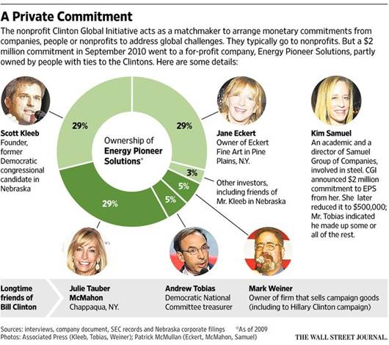

**Sean Spicer Tweet** 5/13/16 8:55 AM

Read [Here](https://twitter.com/seanspicer/status/731105530673025026)

Must click to see cover of [@nypost](https://twitter.com/nypost/) -Clinton charity gave $2M to company owned by Bill’s ‘friend’ Cc [@HillaryClinton](https://twitter.com/HillaryClinton/) [nypost.com/2016/05/13/cli…](https://t.co/mBYiFftqai)

**RNC Research Tweet** 5/13/16 9:46 AM

Read [Here](https://twitter.com/RNCResearch/status/731118217104515073)

VIDEO: Bill Clinton Pressed On Whether CGI Broke Law In Light Of Bombshell WSJ Report [youtu.be/J-rVxJ3LTmE](https://t.co/DbSYyh0srf)

**Raj Shah Tweet** 5/13/16 9:47 AM

Read [Here](https://twitter.com/RajShah84/status/731118374814617600)

VIDEO: Bill Clinton Pressed On Whether CGI Broke Law In Light Of Bombshell WSJ Report [youtu.be/J-rVxJ3LTmE](https://t.co/DbSYyh0srf)

**RNC Tweet** 5/13/16 10:29 AM

Read [Here](https://twitter.com/GOP/status/731129123330883585)

The Clinton Global Initiative aided a for-profit firm part-owned by friends of Hillary Clinton [on.wsj.com/1OrEhYU](https://t.co/XglkvDGQKJ)

**Donald Trump Jr Tweet** 5/13/16 11:49 AM

Read [Here](https://twitter.com/DonaldJTrumpJr/status/731149104311599105)

The Clinton Global Initiative aided a for-profit firm part-owned by Clinton friends [on.wsj.com/1T8Eeqk](https://t.co/ZTrMcwj7tL) via [@WSJ](https://twitter.com/WSJ/)

**Michael C. Short Tweet** 5/13/16 12:11 PM

Read [Here](https://twitter.com/michaelcshort/status/731154586732400640)

VIDEO: Bill Clinton Pressed On Whether [@ClintonGlobal](https://twitter.com/ClintonGlobal/) Broke Law In Light Of Bombshell [@WSJ](https://twitter.com/WSJ/) Report [bit.ly/27k18Bg](https://t.co/xDkfZPmZkn)

**Michael C. Short Tweet** 5/13/16 12:16 PM

Read [Here](https://twitter.com/HouseGOP/status/731156256078041089)

NYP: Clinton charity gave $2M to company owned by Bill’s ‘friend’ [nyp.st/27k2mwo](https://t.co/IySOIlQ4MO)

**Dan Scavino Retweet** 5/13/16 12:25 PM

Read [Here](https://twitter.com/LGlick1/status/731158495245008900)

[**Larry Glick** @LGlick1](https://twitter.com/LGlick1)

Let's make sure we keep them out of the White House in 2017! Let's MAKE AMERICA GREAT AGAIN! [#Trump2016](https://twitter.com/search?q=%23Trump2016) [pic.twitter.com/rlyMnlllos](https://t.co/rlyMnlllos)

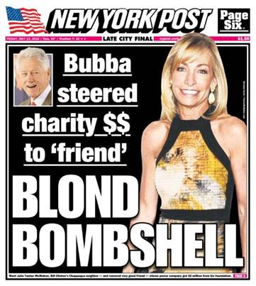

**Katrina Pierson Tweet** 5/13/16 2:41 PM

Read [Here](https://twitter.com/KatrinaPierson/status/731192528171503616)

Crooked... [twitter.com/GOP/status/731…](https://t.co/xUHQC34Nlu)

[**GOP** @GOP](https://twitter.com/GOP)

The Clinton Global Initiative aided a for-profit firm part-owned by friends of Hillary Clinton [on.wsj.com/1OrEhYU](https://t.co/XglkvDGQKJ)

**RNC Research Tweet** 5/13/16 4:05 PM

Read [Here](https://twitter.com/RNCResearch/status/731213555102535681)

VIDEO: CNN’s Alesci On Clinton Foundation Scandal: “It Potentially Creates The Appearance Of A Conflict” [youtu.be/QLqY5ZuVFkA](https://t.co/pI3jKp1jiD)

**Raj Shah Tweet** 5/13/16 4:05 PM

Read [Here](https://twitter.com/RajShah84/status/731213579953815552)

VIDEO: CNN’s Alesci On Clinton Foundation Scandal: “It Potentially Creates The Appearance Of A Conflict” [youtu.be/QLqY5ZuVFkA](https://t.co/mti9RkPfcP)

BACK TO TOP ↑

## Trade

|  |  |
| --- | --- |
| https://pbs.twimg.com/profile_images/1980294624/DJT_Headshot_V2_normal.jpg | **Donald J. Trump (**[**@realDonaldTrump**](https://twitter.com/realdonaldtrump?refsrc=email&s=11)**)** |
| [5/9/16, 8:17 AM](https://twitter.com/realdonaldtrump/status/729646520568524802?refsrc=email&s=11)  "[@Valdosta_Monkey](https://twitter.com/Valdosta_Monkey): [@ChrisCuomo](https://twitter.com/ChrisCuomo) [@realDonaldTrump](https://twitter.com/realDonaldTrump) Is Chris serious, lying or misinformed? Bill Clinton signed NAFTA [pic.twitter.com/dFDvYQrN1v](https://t.co/dFDvYQrN1v)" | |

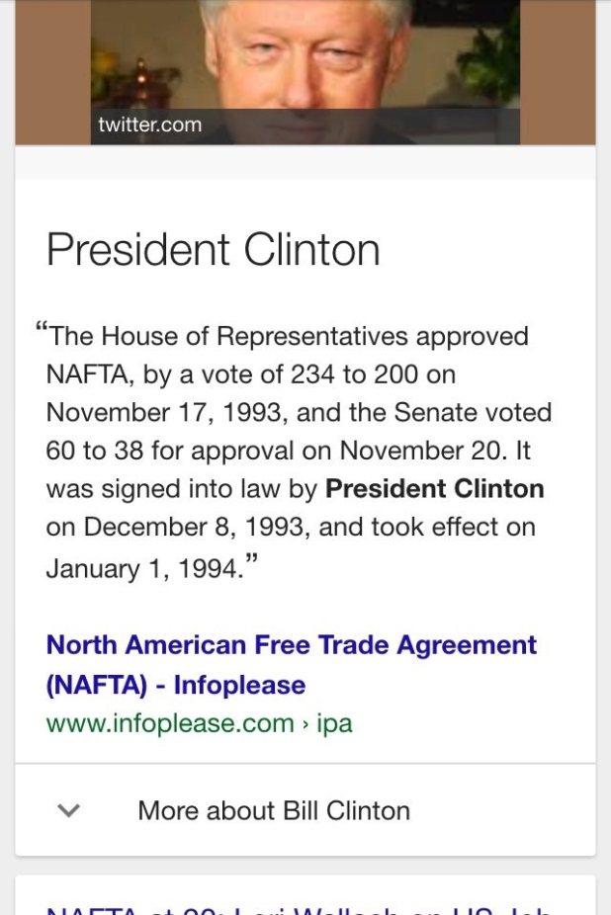

BACK TO TOP ↑

## Healthcare

**RNC Research Tweet** 5/9/16 3:55 PM

Read [Here](https://twitter.com/RNCResearch/status/729761624152788992)

VIDEO: Clinton Can’t Explain Why ObamaCare Raised Small Biz Owner’s Healthcare By $400 [youtu.be/xdNtTM8_wTg](https://t.co/bhYpRS79TL)

**Michael C. Short Tweet** 5/9/16 5:59 PM

Read [Here](https://twitter.com/michaelcshort/status/729792721163005952)

In VA, [@HillaryClinton](https://twitter.com/HillaryClinton/) resurrects the public option, a health care plan so liberal it couldn't pass Dem Congress: [bloom.bg/1YiwVMI](https://t.co/ALuW9Siyky)

BACK TO TOP ↑

## Record as Secretary of State

**America Rising PAC Tweet** 5/9/16 11:01 AM

Read [Here](https://twitter.com/AmericaRising/status/729690168169369602)

NY Dem [@ZephyrTeachout](https://twitter.com/ZephyrTeachout/) Criticizes [@HillaryClinton](https://twitter.com/HillaryClinton/)’s “Disastrous” Libya Intervention [bit.ly/1q99tGb](https://t.co/YzdnX1WFWK) [#ny19](https://twitter.com/search?q=%23ny19) [pic.twitter.com/aLhKf3K2eY](https://t.co/aLhKf3K2eY)

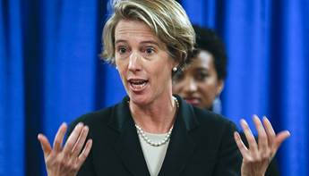

**RNC Tweet** 5/10/16 4:37 PM

Read [Here](https://twitter.com/GOP/status/730134321181298689)

Obama's foreign policy was sold to the American people with lies and the support of Hillary Clinton. [pic.twitter.com/uOTg43V2SP](https://t.co/uOTg43V2SP)

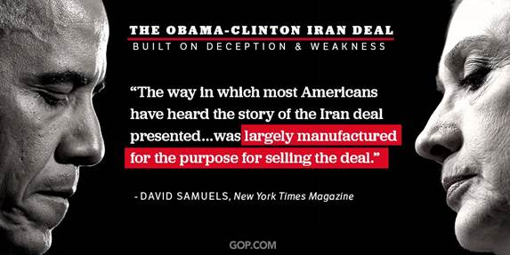

**America Rising PAC Tweet** 5/12/16 11:59 AM

Read [Here](https://twitter.com/AmericaRising/status/730789305421963264)

WATCH: Sidney Blumenthal Grilled On His Unethical Conflicts Of Interest In Libya, Shady Ties To [@HillaryClinton](https://twitter.com/HillaryClinton/) [amp.twimg.com/v/99e097ee-c3e…](https://t.co/Z5bep0WQ12)

**America Rising PAC Tweet** 5/13/16 1:02 PM

Read [Here](https://twitter.com/AmericaRising/status/731167384166240256)

BREAKING: [@HillaryClinton](https://twitter.com/HillaryClinton/)’s Failed Libya Intervention Draws U.S. Troops Back To The Middle East—> [bit.ly/1TeVpFl](https://t.co/lDh3a05hZl)

BACK TO TOP ↑

## Iran

**NRCC Tweet** 5/9/16 10:01 AM

Read [Here](https://twitter.com/NRCC/status/729672230959984640)

Do [@HouseDemocrats](https://twitter.com/HouseDemocrats/) support Sanders plan to normalize relations with Iran or Clinton plan to keep Obama's bad deal? [nrcc.me/1T0LdOr](https://t.co/pOmmLqOF6A)

**NRCC Tweet** 5/9/16 9:59 AM

Read [Here](https://twitter.com/NRCC/status/729672230959984640)

Do [@HouseDemocrats](https://twitter.com/HouseDemocrats) support Sanders plan to normalize relations with Iran or Clinton plan to keep Obama's bad deal?

**NRCC Tweet** 5/9/16 10:44 AM

Read [Here](https://twitter.com/NRCC/status/729683349699219456)

Is [@MorganLCarroll](https://twitter.com/MorganLCarroll) ready to talk [#IranDeal](https://twitter.com/hashtag/IranDeal?src=hash)? Does she stand w/[@HillaryClinton](https://twitter.com/HillaryClinton) or [@BernieSanders](https://twitter.com/BernieSanders)? [#CO06](https://twitter.com/hashtag/CO06?src=hash)

**NRCC Tweet** 5/9/16 11:19 AM

Read [Here](https://twitter.com/NRCC/status/729692248590422016)

Does [@LonBJohnson](https://twitter.com/LonBJohnson) support the [#IranDeal](https://twitter.com/hashtag/IranDeal?src=hash) w/ [@HillaryClinton](https://twitter.com/HillaryClinton) or want to expand it w/ [@BernieSanders](https://twitter.com/BernieSanders)? [#MI01](https://twitter.com/hashtag/MI01?src=hash)

**NRCC Tweet** 5/9/16 11:19 AM

Read [Here](https://twitter.com/NRCC/status/729692364344836097)

Does [@gdriskell](https://twitter.com/gdriskell) side w/ socialist [@BernieSanders](https://twitter.com/BernieSanders) or FBI target [@HillaryClinton](https://twitter.com/HillaryClinton) on [#IranDeal](https://twitter.com/hashtag/IranDeal?src=hash)? [#MI07](https://twitter.com/hashtag/MI07?src=hash)

**NRCC Tweet** 5/9/16 11:20 AM

Read [Here](https://twitter.com/NRCC/status/729692633417826306)

Time for [@TomOHalleran](https://twitter.com/TomOHalleran) to step up. Do you stand with [@HillaryClinton](https://twitter.com/HillaryClinton) or [@BernieSanders](https://twitter.com/BernieSanders) on [#IranDeal](https://twitter.com/hashtag/IranDeal?src=hash)? [#AZ01](https://twitter.com/hashtag/AZ01?src=hash)

**NRCC Tweet** 5/9/16 11:21 AM

Read [Here](https://twitter.com/NRCC/status/729692798505631744)

Which xtreme side does [@GilbertforMI](https://twitter.com/GilbertforMI) take w/ Iran? [@HillaryClinton](https://twitter.com/HillaryClinton) or [@BernieSanders](https://twitter.com/BernieSanders)? [#IranDeal](https://twitter.com/hashtag/IranDeal?src=hash) [#MI08](https://twitter.com/hashtag/MI08?src=hash)

**NRCC Tweet** 5/9/16 11:40 AM

Read [Here](https://twitter.com/NRCC/status/729697554988990464)

Does [@PeteGallego](https://twitter.com/petegallego) stand w/ FBI target [@HillaryClinton](https://twitter.com/HillaryClinton) or socialist [@BernieSanders](https://twitter.com/BernieSanders) on the [#IranDeal](https://twitter.com/hashtag/IranDeal?src=hash)? [#TX23](https://twitter.com/hashtag/TX23?src=hash)

**NRCC Tweet** 5/9/16 11:41 AM

Read [Here](https://twitter.com/NRCC/status/729697786384535552)

Where does extreme [@EmilyAnnCain](https://twitter.com/emilyanncain) stand on the [#IranDeal](https://twitter.com/hashtag/IranDeal?src=hash)? With [@HillaryClinton](https://twitter.com/HillaryClinton) or [@BernieSanders](https://twitter.com/BernieSanders) [#ME02](https://twitter.com/hashtag/ME02?src=hash)

**NRCC Tweet** 5/9/16 12:30 PM

Read [Here](https://twitter.com/NRCC/status/729710110633660416)

Where does [@PeteGallego](https://twitter.com/petegallego) stand on the [#IranDeal](https://twitter.com/hashtag/IranDeal?src=hash)? Does he side with [@HillaryClinton](https://twitter.com/HillaryClinton) or [@BernieSanders](https://twitter.com/BernieSanders)? [#TX23](https://twitter.com/hashtag/TX23?src=hash)

**NRCC Tweet** 5/9/16 12:44 PM

Read [Here](https://twitter.com/NRCC/status/729713554157281281)

.[@MorganLCarroll](https://twitter.com/MorganLCarroll) refuses to talk [#IranDeal](https://twitter.com/hashtag/IranDeal?src=hash). Who does she stand w/ [@HillaryClinton](https://twitter.com/HillaryClinton) or [@BernieSanders](https://twitter.com/BernieSanders)? [#CO06](https://twitter.com/hashtag/CO06?src=hash)

**NRCC Tweet** 5/9/16 12:45 PM

Read [Here](https://twitter.com/NRCC/status/729713857699057664)

Time 4 [@AngieCraigMN](https://twitter.com/AngieCraigMN) 2 tell [#MN02](https://twitter.com/hashtag/MN02?src=hash) voters who she supports on [#IranDeal](https://twitter.com/hashtag/IranDeal?src=hash) [@HillaryClinton](https://twitter.com/HillaryClinton) or [@BernieSanders](https://twitter.com/BernieSanders)

**NRCC Tweet** 5/9/16 1:14 PM

Read [Here](https://twitter.com/NRCC/status/729721195948544000)

Iran test fires missiles again but [@Dr_RaulRuiz](https://twitter.com/Dr_RaulRuiz) stands by [@HillaryClinton](https://twitter.com/HillaryClinton) and the Iran Deal [http://nrcc.me/24H5x2h](https://t.co/W0dLqpqZPv) [#CA36](https://twitter.com/hashtag/CA36?src=hash)

**NRCC Tweet** 5/9/16 1:56 PM

Read [Here](https://twitter.com/NRCC/status/729731872813649920)

Does [@Annette_Taddeo](https://twitter.com/Annette_Taddeo) regret her support of the [#IranDeal](https://twitter.com/hashtag/IranDeal?src=hash) or does she still stand w/ [@HillaryClinton](https://twitter.com/HillaryClinton)? [#FL26](https://twitter.com/hashtag/FL26?src=hash)

**NRCC Tweet** 5/9/16 1:58 PM

Read [Here](https://twitter.com/NRCC/status/729732339878776832)

Does [@ScottPetersCA52](https://twitter.com/ScottPetersCA52) still support [@HillaryClinton](https://twitter.com/HillaryClinton) and her beloved [#IranDeal](https://twitter.com/hashtag/IranDeal?src=hash)? [#CA52](https://twitter.com/hashtag/CA52?src=hash)

**NRCC Tweet** 5/9/16 2:00 PM

Read [Here](https://twitter.com/NRCC/status/729732765147529217)

Will [@HouseDemocrats](https://twitter.com/HouseDemocrats) follow the [@HillaryClinton](https://twitter.com/HillaryClinton) or [@BernieSanders](https://twitter.com/BernieSanders) path on Obama's dangerous Iran deal?

**NRCC Tweet** 5/9/16 2:05 PM

Read [Here](https://twitter.com/NRCC/status/729733945957359617)

Will [@TomOHalleran](https://twitter.com/TomOHalleran) follow [@BernieSanders](https://twitter.com/BernieSanders) lead or support [@HillaryClinton](https://twitter.com/HillaryClinton) approach on [#IranDeal](https://twitter.com/hashtag/IranDeal?src=hash)? [#AZ01](https://twitter.com/hashtag/AZ01?src=hash)

**NRCC Tweet** 5/9/16 2:30 PM

Read [Here](https://twitter.com/NRCC/status/729740309597331456)

.[@Annette_Taddeo](https://twitter.com/Annette_Taddeo) needs 2 own her support for the [#IranDeal](https://twitter.com/hashtag/IranDeal?src=hash) and its biggest supporter [@HillaryClinton](https://twitter.com/HillaryClinton) [#FL26](https://twitter.com/hashtag/FL26?src=hash)

**NRCC Tweet** 5/9/16 2:32 PM

Read [Here](https://twitter.com/NRCC/status/729740745473720320)

.[@JDelaneyforMD](https://twitter.com/JDelaneyforMD) risks natl security by supporting Iran Deal and [@HillaryClinton](https://twitter.com/HillaryClinton) [#MD06](https://twitter.com/hashtag/MD06?src=hash)

**NRCC Tweet** 5/9/16 3:00 PM

Read [Here](https://twitter.com/NRCC/status/729747958363611136)

.[@JDelaneyforMD](https://twitter.com/JDelaneyforMD) doubles down on supporting Iran Deal by backing [@HillaryClinton](https://twitter.com/HillaryClinton) [#MD06](https://twitter.com/hashtag/MD06?src=hash)

**RNC Research Tweet** 5/10/16 5:02 PM

Read [Here](https://twitter.com/RNCResearch/status/730140856779419649)

New From [@RNCResearch](https://twitter.com/RNCResearch/): Liar In Chief [goo.gl/DViI2w](https://t.co/n7U9r0p9ng)

**Raj Shah Tweet** 5/10/16 5:02 PM

Read [Here](https://twitter.com/RajShah84/status/730140872549928962)

New From [@RNCResearch](https://twitter.com/RNCResearch/): Liar In Chief [goo.gl/DViI2w](https://t.co/gFTMgZE9FB)

BACK TO TOP ↑

## SCOTUS

**Dan Scavino Tweet** 5/11/16 1:40 PM

Read [Here](https://twitter.com/DanScavino/status/730452011691421696)

.[@jeffsessions](https://twitter.com/jeffsessions/) warns- if Hillary controls [#SCOTUS](https://twitter.com/search?q=%23SCOTUS) it would be 'the end of law' in America [@SecretsBedard](https://twitter.com/SecretsBedard/) [@dcexaminer](https://twitter.com/dcexaminer/) [washingtonexaminer.com/sessions-warns…](https://t.co/5i6NRkEccW)

BACK TO TOP ↑

## Military

**Corey Lewandowski Tweet** 5/9/16 4:38 PM

Read [Here](https://twitter.com/CLewandowski_/status/729772545470279685)

Survey: Troops prefer Trump to Clinton | TheHill [thehill.com/policy/defense…](https://t.co/BPEnPVVAGW)

**Dan Scavino Tweet** 5/9/16 4:45 PM

Read [Here](https://twitter.com/DanScavino/status/729774413923659776)

Military Times Survey: Troops Prefer [#Trump](https://twitter.com/search?q=%23Trump) to Clinton by a HUGE Margin [#MakeAmericaGreatAgain](https://twitter.com/search?q=%23MakeAmericaGreatAgain) [#Trump2016](https://twitter.com/search?q=%23Trump2016) [militarytimes.com/story/military…](https://t.co/sdHX9JyB47)

BACK TO TOP ↑

## Taxes

**Donald Trump Tweet** 5/10/16 8:58 AM

Read [Here](https://twitter.com/realDonaldTrump/status/730018836808933376)

Why does the media, with a strong push from Crooked Hillary, keep pushing the false narrative that I want to raise taxes. Exactly opposite!

**NRCC Tweet** 5/10/16 9:56 AM

Read [Here](https://twitter.com/NRCC/status/730033621067812864)

Do House Dems support Clinton plan to raise taxes by $498 million or Sanders plan to raise taxes by $13.6 trillion? [nrcc.me/1qbfGRZ](https://t.co/xdHWuesidt)

BACK TO TOP ↑

## Helps People

**Dan Scavino Tweet** 5/10/16 1:46 PM

Read [Here](https://twitter.com/DanScavino/status/730091432363610112)

Who would be most likely to improve the standard of living of the poor? [@greta](https://twitter.com/greta/) Poll: [gretawire.foxnewsinsider.com/poll/clinton-s…](https://t.co/5LOc2cBtPN) [pic.twitter.com/aqXPhwoBKf](https://t.co/aqXPhwoBKf)

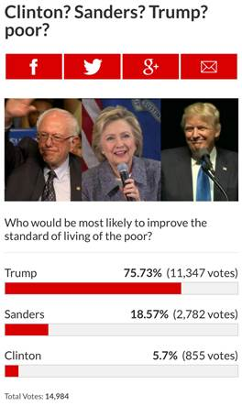

BACK TO TOP ↑

## Coal

**NRSC Tweet** 5/9/16 9:25 AM

Read [Here](https://twitter.com/NRSC/status/729663258634915840)

Hillary Clinton and Ted Strickland want to take away coal miners' jobs. [#OHSen](https://twitter.com/search?q=%23OHSen) [bit.ly/23mA9A2](https://t.co/wvpzhkBYhF) [pic.twitter.com/DRRDmXPUYk](https://t.co/DRRDmXPUYk)

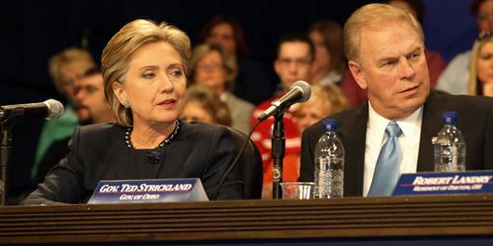

**America Rising PAC Tweet** 5/10/16 10:35 AM

Read [Here](https://twitter.com/AmericaRising/status/730043505536458752)

On [#WVPrimary](https://twitter.com/search?q=%23WVPrimary) Day, A Must-Read From [@politico](https://twitter.com/politico/): “[@HillaryClinton](https://twitter.com/HillaryClinton/) haunted by coal country comment” [politi.co/1Oev6A4](https://t.co/Kvf7Vx2bC5)

**Michael C. Short Tweet** 5/10/16 12:26 PM

Read [Here](https://twitter.com/michaelcshort/status/730071496224350208)

Politico: [@HillaryClinton](https://twitter.com/HillaryClinton/) haunted by coal country comment [politi.co/1UQ6kaZ](https://t.co/zbAEIYxo5X) via [@DanielStrauss4](https://twitter.com/DanielStrauss4/) [#waroncoal](https://twitter.com/search?q=%23waroncoal)

**Michael C. Short Tweet** 5/10/16 2:49 PM

Read [Here](https://twitter.com/michaelcshort/status/730107392705318913)

Washington Post: West Virginia, once [@HillaryClinton](https://twitter.com/HillaryClinton/) Country, leans to Sanders [wapo.st/1rRxQJD](https://t.co/E1aoVAYnx8)

**Reince Priebus Tweet** 5/10/16 6:48 PM

Read [Here](https://twitter.com/Reince/status/730167522415116288)

Obama’s War on Coal devastated Lynn's community & Hillary promises to continue the onslaught [gop.cm/3aorfH](https://t.co/AUHZfubdta) [pic.twitter.com/jiU4PI0EBB](https://t.co/jiU4PI0EBB)

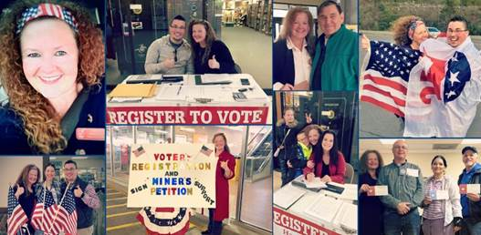

**RNC Research Tweet** 5/10/16 6:59 PM

Read [Here](https://twitter.com/RNCResearch/status/730170347748769792)

An Empty Promise [gop.com/an-empty-promi…](https://t.co/to7sxpfR5f)

**America Rising PAC Tweet** 5/11/16 9:35 AM

Read [Here](https://twitter.com/AmericaRising/status/730390718691172354)

CNN's Dana Bash: [@HillaryClinton](https://twitter.com/HillaryClinton/)’s Coal Comments Were A “Huge Factor” In Her Devastating [#WVPrimary](https://twitter.com/search?q=%23WVPrimary) Loss [amp.twimg.com/v/833439c2-825…](https://t.co/3DwjH1hoKq)

**America Rising PAC Tweet** 5/11/16 1:32 PM

Read [Here](https://twitter.com/AmericaRising/status/730450139635015680)

.[@HillaryClinton](https://twitter.com/HillaryClinton/)’s [#WVPrimary](https://twitter.com/search?q=%23WVPrimary) Numbers Spell Trouble For Coal-Country Dems Like [@KatieMcGintyPA](https://twitter.com/KatieMcGintyPA/) & [@Ted_Strickland](https://twitter.com/Ted_Strickland/): [bit.ly/1sdmSyV](https://t.co/E35taot65K)

**Raj Shah Retweet** 5/11/16 2:11 PM

Read [Here](https://twitter.com/BuzzFeedBen/status/730459963131342848)

[**Ben Smith** @BuzzFeedBen](https://twitter.com/BuzzFeedBen)

Clinton pretty intensely unwelcome in Appalachia , per [@rubycramer](https://twitter.com/rubycramer/) [buzzfeed.com/rubycramer/cli…](https://t.co/GD8eb9mUTe)

|  |  |
| --- | --- |
| https://pbs.twimg.com/profile_images/587309122380398592/vk0k7EA6_normal.png | **RNC Research (**[**@RNCResearch**](https://twitter.com/rncresearch?refsrc=email&s=11)**)** |
| [5/12/16, 8:03 AM](https://twitter.com/rncresearch/status/730730179987935232?refsrc=email&s=11)  New From [@RNCResearch](https://twitter.com/RNCResearch): Bill Travels To Hostile Coal Country [gop.com/bill-travels-t…](https://t.co/Bah0NaPV2P) | |

**Raj Shah Tweet** 5/12/16 10:19 AM

Read [Here](https://twitter.com/RajShah84/status/730764269600550913)

From [@RNCResearch](https://twitter.com/RNCResearch/): Bill Travels To Hostile Coal Country [goo.gl/SgRqmN](https://t.co/plakN64O98)

**America Rising PAC Tweet** 5/13/16 10:06 AM

Read [Here](https://twitter.com/AmericaRising/status/731123118404554753)

.[@thehill](https://twitter.com/thehill/): "Meet the down-ballot Democrats caught up in [@HillaryClinton](https://twitter.com/HillaryClinton/)'s Coal Country catastrophe" [bit.ly/24PYmS2](https://t.co/qwUxzBtrlX) [#WarOnCoal](https://twitter.com/search?q=%23WarOnCoal)

BACK TO TOP ↑

## The “Woman Card”

BACK TO TOP ↑

## Trump

**Donald Trump Rally in Omaha, NE** 5/6/16 5:00 PM

Watch [here](https://toolbox.dnc.org/?tool_name=vantage%20uploader&path=vantageuploader.dnc.org/videos/shared_show?jwt=eyJ0eXAiOiJKV1QiLCJhbGciOiJIUzI1NiJ9.eyJpYXQiOjE0NjI1NzIwNzIsImVtYWlsIjoic3BvbGFyaWNoZ0BkbmMub3JnIiwiaWQiOjMxNjMwMywiZG93bmxvYWRhYmxlIjp0cnVlfQ.lqIBZOf_mHqxIilTo4ZfQbxTedXD7xxCqZn6y1cmmZI)

Take a look at Hillary

* Look at where she’s getting her money
* Bad judgment. Dishonest

[**Sahil Kapur**](https://twitter.com/sahilkapur) [@sahilkapur](https://twitter.com/sahilkapur)

5/6/16 5:28 PM

Read [Here](https://twitter.com/sahilkapur/status/728698070641315841)

Trump on Clinton: "This woman is outta control."

HRC wants to give Obamacare to illegal immigrants

* Our country will be destroyed

|  |  |
| --- | --- |
| https://pbs.twimg.com/profile_images/1980294624/DJT_Headshot_V2_normal.jpg | **Donald J. Trump (**[**@realDonaldTrump**](https://twitter.com/realdonaldtrump?refsrc=email&s=11)**)** |
| [5/6/16, 7:16 PM](https://twitter.com/realdonaldtrump/status/728725179074023425?refsrc=email&s=11)  Goofy Elizabeth Warren, Hillary Clinton’s flunky, has a career that is totally based on a lie. She is not Native American. | |

|  |  |
| --- | --- |
| https://pbs.twimg.com/profile_images/1980294624/DJT_Headshot_V2_normal.jpg | **Donald J. Trump (**[**@realDonaldTrump**](https://twitter.com/realdonaldtrump?refsrc=email&s=11)**)** |
| [5/6/16, 8:16 PM](https://twitter.com/realdonaldtrump/status/728740257512992768?refsrc=email&s=11)  Crooked Hillary Clinton wants completely open borders. Millions of Democrats will run from her over this and support me. | |

**Donald Trump Rally in Eugene, OR** 5/7/16 10:00 PM

Watch [Here](https://toolbox.dnc.org/?tool_name=vantage%20uploader&path=vantageuploader.dnc.org/videos/shared_show?jwt=eyJ0eXAiOiJKV1QiLCJhbGciOiJIUzI1NiJ9.eyJpYXQiOjE0NjI1OTE2MzEsImVtYWlsIjoibm9yZHlrZWhAZG5jLm9yZyIsImlkIjozMTYzMjcsImRvd25sb2FkYWJsZSI6dHJ1ZX0.3yGgPOMTLVtCgaNSyDlerjp5vUtjNGijhCe2OuN7Fs8)

Trump complains about having to say "people" instead of "men"

- HRC would call me sexist

Attacking Elizabeth Warren as a "goofus" and a "basket case"

- Done nothing in the Senate

- She is 5% native american. Her whole career based on her being a minority

- HRC should run with goofy Elizabeth Warren

HRC would get nowhere without woman card

- Wall Street friends

- I know her Wall Street friends better than she does

Women want strength, and border security, and military

- They don't want somebody who was sleeping

- NAFTA was signed by "The Clintons"

Nobody was worse in the history of the country politically than Bill Clinton with women

- HRC was an enabler. Have you heard what HRC did to the women Bill had affairs with?

Hitting HRC on coal miners comments

- All talk, no action

- Just like Elizabeth Warren

HRC totally controlled by those who gave her money

- Says he will beat Hillary

- The polls are already showing it

|  |  |
| --- | --- |
| https://pbs.twimg.com/profile_images/1980294624/DJT_Headshot_V2_normal.jpg | **Donald J. Trump (**[**@realDonaldTrump**](https://twitter.com/realdonaldtrump?refsrc=email&s=11)**)** |
| [5/7/16, 11:47 AM](https://twitter.com/realdonaldtrump/status/728974420807581696?refsrc=email&s=11)  I am going to keep our jobs in the U.S., and totally rebuild our crumbling infrastructure. Crooked Hillary has no clue! [@Teamsters](https://twitter.com/Teamsters) | |

**Donald Trump Rally in Spokane, WA** 5/7/16 3:00 PM

Watch [here](https://toolbox.dnc.org/?tool_name=vantage%20uploader&path=vantageuploader.dnc.org/videos/shared_show?jwt=eyJ0eXAiOiJKV1QiLCJhbGciOiJIUzI1NiJ9.eyJpYXQiOjE0NjI2NTM5MzMsImVtYWlsIjoic3BvbGFyaWNoZ0BkbmMub3JnIiwiaWQiOjMxNjM0OCwiZG93bmxvYWRhYmxlIjp0cnVlfQ.9FG_S13whLdZnbMFmBCdCoZonp6E_9NMx4ZNYw-oH88)

Hillary Clinton cut her speech short because of a protester. Only 11-13 minutes

- But you people waited in line. They don't have that problem

WV miners endorsed me

- HRC wants all miners essentially fired

- Those apologies don't work. They know how you really feel

HRC will run $90 million in "women oriented" ads

- Would have no chance if she didn't play the women card

- Can't raise your voice to a woman

- Megyn Kelly comments: Didn't get a chance to finish my sentence. People have dirty minds

- We had fun on Howard Stern. The last thing in the world I wanted to do was [run for office]

- HRC's husband was biggest abuser of women in history of politics

- Married to a man who got impeached for lying about what happened to a woman

- HRC was an enabler. And she's going to take ads against me?!

HRC wants to get rid of miners and keep wages low

**Donald Trump Rally in Lynden, WA** 5/7/16 6:00 PM

Watch [here](https://toolbox.dnc.org/?tool_name=vantage%20uploader&path=vantageuploader.dnc.org/videos/shared_show?jwt=eyJ0eXAiOiJKV1QiLCJhbGciOiJIUzI1NiJ9.eyJpYXQiOjE0NjI2NjUzNzYsImVtYWlsIjoic3BvbGFyaWNoZ0BkbmMub3JnIiwiaWQiOjMxNjM1MSwiZG93bmxvYWRhYmxlIjp0cnVlfQ.maGxwoG7giFCQh7DZpwk_RInAjgNyoIItZUYvIhVVaM)

Crooked Hillary running ads against me

The last person Crooked Hillary Clinton wants to run against is Trump

- She will be worse than Obama

- Goofy Elizabeth Warren. Done nothing in the Senate.

- You're not allowed to say Indian, so I'll say Native American

- She said she thought she was Native American because her mom had high cheekbones

- Whole career is a fraud

- HRC is too smart to pick Elizabeth Warren

Hits HRC as being "trigger happy" on foreign policy

- She has a bad temperament. Her husband found that out a few times

HRC was sleeping at 3am for the phone call

HRC wants to abolish the 2nd amendment

- Wants to take your guns and bullets away

HRC might appoint 5 new justices

- You would have a Supreme Court that would destroy our country

HRC buying $90 million in ads against me

- Her husband was biggest abuser of women in history of politics

- TRUMP: "I'm like a baby. A baby."

- Trump mocks Bill Clinton "I did not have sex with that woman" line

Sympathizing with Bernie Sanders

- No fan of the guy, but system is rigged

**Donald Trump Interview on ABC This Week** 5/8/16 9:05 AM

Trump Part [One](https://toolbox.dnc.org/?tool_name=vantage%20uploader&path=vantageuploader.dnc.org/videos/shared_show?jwt=eyJ0eXAiOiJKV1QiLCJhbGciOiJIUzI1NiJ9.eyJpYXQiOjE0NjI3MTU5MTEsImVtYWlsIjoiYmhhdG5hZ2FyYUBkbmMub3JnIiwiaWQiOjMxNjM1NywiZG93bmxvYWRhYmxlIjp0cnVlfQ.gSwAxACQT9b02Nv5DPDRQZ8iAvv0TKhUKbqL8wPHqYg)

Trump Part [Two](https://toolbox.dnc.org/?tool_name=vantage%20uploader&path=vantageuploader.dnc.org/videos/shared_show?jwt=eyJ0eXAiOiJKV1QiLCJhbGciOiJIUzI1NiJ9.eyJpYXQiOjE0NjI3MTU5NTEsImVtYWlsIjoiYmhhdG5hZ2FyYUBkbmMub3JnIiwiaWQiOjMxNjM1OCwiZG93bmxvYWRhYmxlIjp0cnVlfQ.TJkW5DVUoirVUROzXQuRGh-dU67UwPWeGytABc8mmCo)

>> You're not worried about Obama out there campaigning against you?   
>> Hillary Clinton. The only thing she has going. She plays the woman card 100%. I saw her in a speech. Megyn Kelly was terrific. She called me and came up to my office. She wanted to make peace. And, we did. We did. I mean, it was very nice. Some of the stuff is said as, you know, an entertainer. Because I have "The apprentice." Some was said in fun with shows like "Hourld stern" you're a friend of mine.   
>> You're not worried about the tapes of that coming back?   
>> What am I going to do. What the politicians say behind the scenes make whatever I said jokingly to Howard and other people like baby stuff. What they say behind the keeps talking about everything is far worse than anything you have seen or will see about me.   
And they act like, oh, that's so terrible. So terrible. I mean, you know, it's called give me a break. I watch Hillary Clinton like she's a baby. Look what happens with her family. I watch her, like, oh the way he talks to women. The way he talks to women. Well, take a look at her husband and what do you think he talks to women? So when I watch her, she's playing the woman's card so much. And so loud. And frankly, I think it's her only chance of getting elected. Listen, she's going to get -- she's going to get hit for it. Because it's not appropriate.

>> Nobody in this country and maybe in the history of the country politically was worse than Bill Clinton with women. He was a disaster.   
>> And Saturday.   
>> Hillary Clinton's husband abused women more than any man that we know of in the history of politics, right? She's married to a man who was the worst abuser of women in the history of politics. She's married to a man who hurt many women. And Hillary, if you look and see study, Hillary hurt many women.

**Donald Trump Interview on Meet the Press** 5/8/16

Part [Two](https://toolbox.dnc.org/?tool_name=vantage%20uploader&path=vantageuploader.dnc.org/videos/shared_show?jwt=eyJ0eXAiOiJKV1QiLCJhbGciOiJIUzI1NiJ9.eyJpYXQiOjE0NjI3MTYxMDIsImVtYWlsIjoiYmhhdG5hZ2FyYUBkbmMub3JnIiwiaWQiOjMxNjM2MCwiZG93bmxvYWRhYmxlIjp0cnVlfQ.GgldPBjNL_T3c1XmudvxShTC3e9tE-4-VRiWeYE7T5A)

>> another contradiction has been on your feelings toward hillary clinton. in 2012, as she was leaving secretary of state, you praised her. you thought she did a good job. you said, you know what, she's not pushing her agenda. she had to carry on someone else's agenda. before that, you didn't fault her on the iraq war vote because you said, you know what, she got bad intelligence like a lot of other people got. now –

>> didn't get bad intelligence. i didn't get bad intelligence.

>> i understand that. you said you kind of forgave her on that early on. now you're calling her, she's been crooked from the start. this goes back to, which donald trump do we believe on your feelings toward hillary clinton? 2012 or now?

> okay. so recently, a magazine said donald trump is a world class businessman, and i am. i built an amazing company, some of the greatest assets in the world, just great stuff, all over the world. i go all over the world. i'm in europe, in asia, all over the world. i'm not looking to get in fights with politicians. i'm not looking to get in fights with the secretary of state, so when i do something in a country, wherever it may be, in dubai, where i'm doing big jobs and other places, in china where i'm actually getting ready to sign big jobs through my company. i want to get along with politicians. when somebody says, what do you think of hillary clinton? number one, i'm not looking at it that closely because i'm in business. but when somebody says, three, four, five years ago, let's look at hillary clinton, what do you think? she's doing great. i say everybody

**Paul Manafort on Fox News Sunday** 5/8/16

[Manafort](https://toolbox.dnc.org/?tool_name=vantage%20uploader&path=vantageuploader.dnc.org/videos/shared_show?jwt=eyJ0eXAiOiJKV1QiLCJhbGciOiJIUzI1NiJ9.eyJpYXQiOjE0NjI3MTU3OTksImVtYWlsIjoiYmhhdG5hZ2FyYUBkbmMub3JnIiwiaWQiOjMxNjM1NiwiZG93bmxvYWRhYmxlIjp0cnVlfQ.kMFUy_O1w3R-gI27XC6sRoIMhG9quDJAAb2JFrWPy0c)

Wallace: Trump says he’ll not get personnel with Hillary…then got personal by blaming the demise of the women who Bill had affairs with on Hillary’s cruelty.  What specifically did Hillary do to those women?

Manafort: Donald Trump is not going to allow hypocrisy on the women’s issue.

Wallace: What did HRC to do those women?

Manafort: I’ll let him speak to the issue. Trump is very pro-women, more so than Hillary Clinton.

Wallace: Trump got in Twitter fight with Warren. Do you really want to take on two women? Seems dangerous.

Manafort: Trump’s just taking on two politicians. Hillary and Warren don’t get to hide behind their sex.

Wallace: Trump says he’s self-funding. He’s not. Does that mean Trump can be bought?

Manafort: Self-funding is for primaries. We’re in the big show now, the general. So it’ll be a united effort to get him in.

Wallace: Repeats question.

Manafort: That’s correct Trump will get some money from people as head of the party. He takes the money because it’d be irresponsible to let Hillary, Pelosi, and Gary[sic] Reid stay in power.

Wallace: So Trump’s being bought.

Manafort: No, Hillary’s being bought. Not Trump. Trump employs 100s of 1000s of people.

**Donald Trump Tweet** 5/8/16 4:15 PM

Read [Here](https://twitter.com/realDonaldTrump/status/729404337164783617)

Crooked Hillary just can't close the deal with Bernie. It will be the same way with ISIS, and China on trade, and Mexico at the border. Bad!

**Donald Trump on CNN** 5/9/16 7:00 AM

Watch [here](https://toolbox.dnc.org/?tool_name=vantage%20uploader&path=vantageuploader.dnc.org/videos/shared_show?jwt=eyJ0eXAiOiJKV1QiLCJhbGciOiJIUzI1NiJ9.eyJpYXQiOjE0NjI3OTM4NDEsImVtYWlsIjoiYmhhdG5hZ2FyYUBkbmMub3JnIiwiaWQiOjMxNjM5NywiZG93bmxvYWRhYmxlIjp0cnVlfQ.2GK8-plF7U6pgf7_JxaoQw6SNURp8KhtborBzKMn3eg)

Attacks on HRC?

* “This is a nice way to start off the interview. First of all, you should congratulate me.”
* Calls CNN the Clinton network
* Says trade was the first thing he came out with, not attacks on HRC
* HRC wants to put coal miners out of business

Maintaining the G.I Bill the way it is, as opposed to cutting it?

* Will do nothing to hurt our vets
* HRC thinks vets are getting too much

Is that a yes that you support current G.I. Bill?

* No. I want to bring jobs back
* Hits Clinton on NAFTA
* (Cuomo corrects him that Bush 41 was also responsible for NAFTA)

Why attacking Clintons on infidelity and women’s card?

* Retribution for what she said. She’s playing the womens card
* He was the worst abuser of women
* Impeached for lying
* She can’t talk about me

Sarah Palin on Paul Ryan?

* I guess she’s endorsing somebody that’s opposing Paul Ryan
* I’ve always liked Ryan. Then I got blindsided
* People are tired of being lied to. Like HRC with 3am phone call and Benghazi

**Donald Trump on Fox Business with Bartiromo** 5/9/16 7:30 AM

Watch [here](https://toolbox.dnc.org/?tool_name=vantage%20uploader&path=vantageuploader.dnc.org/videos/shared_show?jwt=eyJ0eXAiOiJKV1QiLCJhbGciOiJIUzI1NiJ9.eyJpYXQiOjE0NjI3OTUxNzksImVtYWlsIjoiYmhhdG5hZ2FyYUBkbmMub3JnIiwiaWQiOjMxNjM5OCwiZG93bmxvYWRhYmxlIjp0cnVlfQ.0Gyiy4E4FdN-sKB4spXROKQimImAhIIGaGCqt9Kc_H0)

HRC will be a disaster

**Katrina Pierson and Marsha Blackburn on Fox Business** 5/9/16 6:00 PM

[Watch](https://toolbox.dnc.org/?tool_name=vantage%20uploader&path=vantageuploader.dnc.org/videos/shared_show?jwt=eyJ0eXAiOiJKV1QiLCJhbGciOiJIUzI1NiJ9.eyJpYXQiOjE0NjI4MzQyODMsImVtYWlsIjoibm9yZHlrZWhAZG5jLm9yZyIsImlkIjozMTY5MzIsImRvd25sb2FkYWJsZSI6dHJ1ZX0.3Ykv-0BojoqirP66y9C_7GLDfSDIUZUPhxuMt76xyjA)

HRC is trying paint Trump as a misogynist

HRC’s role in aftermath of Bill Clinton’s infidelity

**Donald Trump Tweet** 5/10/16 9:58 AM

Read [Here](https://twitter.com/realDonaldTrump/status/730034041760690176)

It was Rosie O'Donnell who ate the cake in the vicious Hillary commercial about me, not Crooked Hillary! [@marthamaccallum](https://twitter.com/marthamaccallum/)

**Donald Trump Tweet** 5/10/16 1:32 PM

Read [Here](https://twitter.com/realDonaldTrump/status/730087830790275077)

Hillary has bad judgement! [instagram.com/p/BFPCtFfmhWB/](https://t.co/LhcIU6kmxs)

**Donald Trump Instagram** 5/10/16 1:26 PM

Watch [Here](https://www.instagram.com/p/BFPCtFfmhWB/)

Hillary has bad judgement!

Video: shows clips of Patricia Smith, sister of Glen Doherty, Charles Wood saying HRC lied about Benghazi attacks related to video being the cause. HRC laughing during Benghazi Committee testimony. Ends onscreen “NEVER FORGET!”

**Donald Trump Tweet** 5/10/16 1:41 PM

Read [Here](https://twitter.com/realDonaldTrump/status/730089913778065408)

Hillary has bad judgment! [instagram.com/p/BFPCtFfmhWB/](https://t.co/LhcIU6kmxs)

**Donald Trump Tweet** 5/10/16 3:32 PM

Read [Here](https://twitter.com/realDonaldTrump/status/730118084040724482)

The Clintons spend millions on negative ads on me & I can’t tell the truth about her husband? Don’t feel sorry for crooked Hillary!

**Donald Trump Facebook Post** 5/12/16 9:00 AM

Read [Here](https://www.facebook.com/DonaldTrump/posts/10157035729655725)

"Speaker [Newt Gingrich](https://www.facebook.com/newtgingrich/) pointed out the pay disparity between male and female executives at the Clinton Foundation, where men earn 38 percent more on average, before telling viewers that Trump is more pro-woman than the former secretary of state. He also noted that this likely would come as a "shock" to many voters."

**Donald Trump Jr Tweet** 5/12/16 10:33 AM

Read [Here](https://twitter.com/DonaldJTrumpJr/status/730767699559763969)

Gingrich: Trump more 'pro-woman' than Clinton. Clinton Foundation, men earn 38 percent more [washex.am/1s0Ugbq](https://t.co/HCYcinYP3t) via [@dcexaminer](https://twitter.com/dcexaminer/)

[**Newly Launched Super PAC Vows to Raise Millions for Donald Trump**](http://abcnews.go.com/Politics/newly-launched-super-pac-vows-raise-millions-donald/story?id=39074969)

**ABC News**

**5/12/16**

As presumptive Republican nominee [Donald Trump](http://abcnews.go.com/topics/news/donald-trump.htm) shifts his campaign to the general election, at least one super PAC is getting on board too.

A brand new pro-Trump super PAC launched today, touting its ability to take on Democratic front-runner Hillary Clinton through a major donor operation focused on funding voter registration programs, get-out-the-vote operations, and television and online media ad buys.

Representatives for the group, called the Committee for American Sovereignty, say they expect to raise $20 million between now and the GOP convention in July and upwards of $100 million throughout the course of the campaign.

Doug Watts, national executive director and spokesman for the group, who also served as a former adviser to [Ben Carson](http://abcnews.go.com/topics/news/us/ben-carson.htm), told ABC News that the group's mission is to combat the "Clinton machine."

“With the recent announcement that a pro-Hillary Clinton super PAC has already booked over $90 million in ad time in just seven states in June, it is clear we need to ramp up major donor fundraising efforts, unify Republicans, and take on the Clinton machine. We have already begun to raise significant funds in California and from supporters across the country," Watts said.

The advisory committee to the Committee for American Sovereignty includes military leaders, the former chairman of Trump Resorts International and political activists from across the country.

**Michael Cohen on CNN** 5/10/16 5:30 PM

[Michael Cohen on CNN](https://toolbox.dnc.org/?tool_name=vantage%20uploader&path=vantageuploader.dnc.org/videos/shared_show?jwt=eyJ0eXAiOiJKV1QiLCJhbGciOiJIUzI1NiJ9.eyJpYXQiOjE0NjI5MTc1MDcsImVtYWlsIjoiYmhhdG5hZ2FyYUBkbmMub3JnIiwiaWQiOjMxNzMwMCwiZG93bmxvYWRhYmxlIjp0cnVlfQ.kEouTpktvsd4WzQiwLhfJuz7K5_W9hCq9ds1mQHrvhM)

**Q. All these people who signed a pledge to support aren’t exactly jumping on right now, what does that tell you?**

It doesn’t tell me anything

Basically it means it will take them  longer to come on board, but Mr. Trump will bring everybody together it’s what he does

He will be the great unifier

To use the metaphor of the wall, it’s really HRC who is a dogmatic democrat who has actually built a wall across the aisle

Donald Trump will build a bridge, he will bring Dems and GOPers together

Maybe you don’t like everything he’s said, that’s fine

He’ll fix the economy, create jobs, ensure America is safe

**Q. New Q-Poll shows HRC and trump neck and neck in key battlegrounds, but look at women voters, what does he need** **to do to get more women to support him**

he needs to be himself

He hasn’t started campaigning against HRC yet

Women like men are interested in three htings, jobs, economy & security

Trump is beating HRC in all three of these areas

**Q. Do you think it is smart to keep going after WJC and HRC over sexual indiscretions back in the 90s?**

Let’s not forget it was HRC that came out with her Super PAC calling Trump a sexist, mysognist

Trump is a counter puncher, if you’re going to call him something be prepared for what is going to come back

**Paul Manafort on MSNBC** 5/10/16 7:07 PM

- Playing clips of Trump attacking HRC over Bill Clinton

- Manafort says Trump will definitely be talking about this during the campaign. Pressed on whether or not they actually have a case here, Manafort says “stay tuned”

- Clintons have never run against Donald Trump

**Donald Trump on O'Reilly Factor** 5/10/16 8:00 PM

Watch [here](https://toolbox.dnc.org/?tool_name=vantage%20uploader&path=vantageuploader.dnc.org/videos/shared_show?jwt=eyJ0eXAiOiJKV1QiLCJhbGciOiJIUzI1NiJ9.eyJpYXQiOjE0NjI5MjY1NzcsImVtYWlsIjoicGV0ZXJzb25rQGRuYy5vcmciLCJpZCI6MzE3MzIxLCJkb3dubG9hZGFibGUiOnRydWV9.zclDfa-R5WPSq15wzTaWL_lUAYBKEpKESMaU7m8uvKc)

Elizabeth Warren attacks on you?

- She has done nothing.

- Scott Brown told me bad things about her

- Attacking me because she sees polls that I will beat Hillary

- Amazing Twitter rant. I responded. Haven't heard from her since

**Donald Trump on Fox and Friends** 5/11/16 7:10 AM

Part [One](https://toolbox.dnc.org/?tool_name=vantage%20uploader&path=vantageuploader.dnc.org/videos/shared_show?jwt=eyJ0eXAiOiJKV1QiLCJhbGciOiJIUzI1NiJ9.eyJpYXQiOjE0NjI5NzE4MzUsImVtYWlsIjoiYmhhdG5hZ2FyYUBkbmMub3JnIiwiaWQiOjMxNzM0MiwiZG93bmxvYWRhYmxlIjp0cnVlfQ.rXWw5M75lNzt8gpJjbTHOhItbBH3XlCMwVyQdv0opHw), [Two](https://toolbox.dnc.org/?tool_name=vantage%20uploader&path=vantageuploader.dnc.org/videos/shared_show?jwt=eyJ0eXAiOiJKV1QiLCJhbGciOiJIUzI1NiJ9.eyJpYXQiOjE0NjI5NzE4MTAsImVtYWlsIjoiYmhhdG5hZ2FyYUBkbmMub3JnIiwiaWQiOjMxNzM0MywiZG93bmxvYWRhYmxlIjp0cnVlfQ.MQB__PhCbJNCacL3qa3dks69PxS8x6zbiwS6BLGUOTc)

We’re going to put the miners back to work

Hillary Clinton wants to close the mines

I don’t know how she can get any votes frankly… She’s got problems

Crazy Bernie

Everything about Hillary is rigged

How can she run with what happened with the emails?

I call him crazy Bernie because he’s not very good

Who’s going to run against a socialist and lose. You will pay 95% tax

**Donald Trump on Imus in the Morning** 5/11/16 10:00 AM

Listen [here](https://toolbox.dnc.org/?tool_name=vantage%20uploader&path=vantageuploader.dnc.org/videos/shared_show?jwt=eyJ0eXAiOiJKV1QiLCJhbGciOiJIUzI1NiJ9.eyJpYXQiOjE0NjI5NzUwODUsImVtYWlsIjoiamFrdWJpZWNtQGRuYy5vcmciLCJpZCI6MzE3MzU0LCJkb3dubG9hZGFibGUiOnRydWV9.6KVJ8iTV7Ksmisbc869qMa0cV8WqfjOiyaod3h2aA0w)

Tyson said “everybody has a plan until they get punched.” Clintons didn’t expect Bernie challenge. Are they prepared?

HRC can’t make great trade deals

Libya, Benghazi were a disaster. So many things she handled so badly

She wants to abolish the 2nd amendment. She essentially wants to abolish the 2nd amendment and take guns away

I will eliminate waste, fraud, and abuse. Other countries are ripping us off

**Donald** **Trump on Kilmeade Radio Show** 5/11/16

Listen [here](https://toolbox.dnc.org/?tool_name=vantage%20uploader&path=vantageuploader.dnc.org/videos/shared_show?jwt=eyJ0eXAiOiJKV1QiLCJhbGciOiJIUzI1NiJ9.eyJpYXQiOjE0NjI5ODM0NzUsImVtYWlsIjoiamFrdWJpZWNtQGRuYy5vcmciLCJpZCI6MzE3NTg3LCJkb3dubG9hZGFibGUiOnRydWV9.zyvgSC17POmHPx9Pms_HVtKvFCcYIBLcV-03X_7JGlk)

Game plan for Sanders matchup?

Rigged system, so it won’t happen

Super delegates handed to them by the bosses

HRC will win

She has another problem with the FBI. Bad judgment

Will Biden be brought in if HRC is indicted? Would Biden have been tougher opponent than HRC?

His son was a great guy. Biden took it very tough

They would like to bring him in. They don’t like Sanders. But it would be hard to take away from Sanders

**Donald Trump on Mike Gallagher Show** 5/11/16

Saved [here](https://toolbox.dnc.org/?tool_name=vantage%20uploader&path=vantageuploader.dnc.org/videos/shared_show?jwt=eyJ0eXAiOiJKV1QiLCJhbGciOiJIUzI1NiJ9.eyJpYXQiOjE0NjI5ODg2NjYsImVtYWlsIjoiYmhhdG5hZ2FyYUBkbmMub3JnIiwiaWQiOjMxNzU5NywiZG93bmxvYWRhYmxlIjp0cnVlfQ.fC5GsXyGhIVWSfFrw--2W4C10EwXKgcBY623lZxVAEs)

**Exit polls from last night?**

Bernie’s voters will come over to me

We will put miners back to work. Hillary said exactly the opposite.

Rather face Hillary, Bernie, or Biden?

Doesn’t matter

Getting harder and harder for Hillary. Loses every single week, but it’s a rigged deal

Email scandal is a rigged deal too. She’s lost her mojo

**Paul Ryan?**

Ryan loves the party, loves the country

He sees my poll numbers going up rapidly

**Never Trump crowd. Why is it so personal for them?**

Can’t explain it. I am an outsider

Beating HRC in polls in FL, PA, OH

**Cruz not supporting you. Rubio says he won’t support Clinton. Won’t attack you?**

Rubio did the right thing.

Cruz will come around

Jeb spent $12 million on phony ads, so he can’t endorse. Violated pledge, not a man of honor

Unity is better. Gives us a better chance to beat Hillary

**Sealing the deal with those on the fence with you?**

They’re coming along

Trade, Obamacare, vets, border, 2nd amendment

HRC wants to abolish the 2nd amendment, take away everyones guns

**Donald Trump On The Record with Greta** 5/11/16 7:00 PM

[Part 1](https://toolbox.dnc.org/?tool_name=vantage%20uploader&path=vantageuploader.dnc.org/videos/shared_show?jwt=eyJ0eXAiOiJKV1QiLCJhbGciOiJIUzI1NiJ9.eyJpYXQiOjE0NjMwMDk2NzQsImVtYWlsIjoibG9nYW5vQGRuYy5vcmciLCJpZCI6MzE3Njc3LCJkb3dubG9hZGFibGUiOnRydWV9.-lV7ZuKohykYkLCzbmzJUfxyoVPUhpL5Sk3gbaW-Afs)

**Muslim Ban?**

Temporary. Aim is to have it lifted

Have great Muslim friends telling me ‘You are so right.”

5-7 person commission to deal with problem

Rudy Giuliani already agreed to lead

“Have to have exceptions… Ideally you won’t have a ban very long”

Have to build a safe zone funded by Gulf States… We don’t have the money

Against having more people flow

Hillary Clinton wants to double or triple the effort [to bring in refugees]

**Baghdad bombing?**

Should never have been in Iraq

Hillary Clinton has bad judgment.

“It is a hell hole. It is a mess.”

Totally corrupt government there

**Sarah** **Huckabee Sanders on CNN** 5/12/16 9:40 AM

Watch [here](https://toolbox.dnc.org/?tool_name=vantage%20uploader&path=vantageuploader.dnc.org/videos/shared_show?jwt=eyJ0eXAiOiJKV1QiLCJhbGciOiJIUzI1NiJ9.eyJpYXQiOjE0NjMwNjI2NjcsImVtYWlsIjoiamFrdWJpZWNtQGRuYy5vcmciLCJpZCI6MzE3NzI0LCJkb3dubG9hZGFibGUiOnRydWV9.PhSu4jchmkOTz_QP97GYqk7ROu3wTjld8QylxWc9szE)

OK if HRC didn’t release her returns?

She has far bigger things to be concerned about

**Donald Trump on Hannity** 5/12/16 10:00 PM

[Part One](https://toolbox.dnc.org/?tool_name=vantage%20uploader&path=vantageuploader.dnc.org/videos/shared_show?jwt=eyJ0eXAiOiJKV1QiLCJhbGciOiJIUzI1NiJ9.eyJpYXQiOjE0NjMxMDYyMDksImVtYWlsIjoicG9sc29uakBkbmMub3JnIiwiaWQiOjMxODA4NSwiZG93bmxvYWRhYmxlIjp0cnVlfQ.skThYySIMH3aEDqt26015zt9Bib4z64zM809CYprrVw)

[Part Two](https://toolbox.dnc.org/?tool_name=vantage%20uploader&path=vantageuploader.dnc.org/videos/shared_show?jwt=eyJ0eXAiOiJKV1QiLCJhbGciOiJIUzI1NiJ9.eyJpYXQiOjE0NjMxMDY3MTgsImVtYWlsIjoicG9sc29uakBkbmMub3JnIiwiaWQiOjMxODA4NiwiZG93bmxvYWRhYmxlIjp0cnVlfQ.94UbOPQlXHwf_4iHEYeNVBQvIV0BrPrgkd9FFq0Vu8E)

**Jobs as biggest problem?**

- HRC wants to put the miners out of business

- HRC is like a job killing machine

- Husband killed NAFTA

**HRC never talks about Saudis. Did they buy her silence?**

- I talk about the emails all the time

- System rigged against Bernie

- Clinton Foundation has some big problems. Movie that's coming out is brutal

**HRC can't close out nomination?**

- Not a closer here. Not a closer last time

- Not a closer with China. Won't be a closer on ISIS

- This is not a woman that should be president. I don't think she can do it

**Donald Trump on the Today Show** 5/13/16 7:10 AM

[Today](https://toolbox.dnc.org/?tool_name=vantage%20uploader&path=vantageuploader.dnc.org/videos/shared_show?jwt=eyJ0eXAiOiJKV1QiLCJhbGciOiJIUzI1NiJ9.eyJpYXQiOjE0NjMxMzg4MjcsImVtYWlsIjoiYmhhdG5hZ2FyYUBkbmMub3JnIiwiaWQiOjMxODA5MCwiZG93bmxvYWRhYmxlIjp0cnVlfQ.TrUzNzW--O95lOhfDYQq8vjpTnDY_qSc-6J9U8CGqmQ)

Thinks he'll win the election because HRC is a disaster, assuming she even gets to run

**Donald Trump on GMA** 5/13/16

[GMA](https://toolbox.dnc.org/?tool_name=vantage%20uploader&path=vantageuploader.dnc.org/videos/shared_show?jwt=eyJ0eXAiOiJKV1QiLCJhbGciOiJIUzI1NiJ9.eyJpYXQiOjE0NjMxMzg5NjMsImVtYWlsIjoiYmhhdG5hZ2FyYUBkbmMub3JnIiwiaWQiOjMxODA5MSwiZG93bmxvYWRhYmxlIjp0cnVlfQ.r5NxGgElNEukGE1M86UnCW18eYpIkW_aBqPycZDz3vM)

**Do voters have the right to see your tax returns?**

I don't think so

I will gladly release them when audit ends, that should be before the election

I laugh when Mrs. Clinton says that: when will she give emails or Goldman transcripts?

I get audited every single year

**You said you'd release them when Obama released his birth certificate, then you said you'd do it when HRC released her emails, and she's released all the ones in her possession...**

she didn't turn over her emails, there are plenty missing

I know she's a good friend of yours and you worked for them and you didn't reveal it, but she did not

the whole thing is a scam

**Donald Trump on Fox & Friends** 5/13/16

Watch [here](https://toolbox.dnc.org/?tool_name=vantage%20uploader&path=vantageuploader.dnc.org/videos/shared_show?jwt=eyJ0eXAiOiJKV1QiLCJhbGciOiJIUzI1NiJ9.eyJpYXQiOjE0NjMxNDAwNjAsImVtYWlsIjoiYmhhdG5hZ2FyYUBkbmMub3JnIiwiaWQiOjMxODA5MiwiZG93bmxvYWRhYmxlIjp0cnVlfQ.tInY9rXI31pktTpD06zomXcF88-5TfaZtt534ZcZTHo)

**NY Post “Blond Bombshell” story. Bill Clinton steered Foundation money to a company owned by a woman Bill may have been involved with?**

I’ve been hearing about this for years

I hope you put the word “charity” in quotes regarding foundation

HRC plays the women card, I have to hit back