EVENT MEMO

City, State

Month Day, 2013

Event Name

DATE: Month Day, 2013
LOCATION:
TIME:
FROM:

- PURPOSE:

[Briefly (a few sentences or 1-2 paragraphs) explain why the VP is attending this event, who will be there, etc.]

- PARTICIPANTS:

- YOU
- # [photoline participants, dinner attendees, supporters, etc.]
.
- PRESS PLAN:

This event will be CLOSED press.

- SEQUENCE OF EVENTS:

[Write out tic toc of the event. Example is below.]

- YOU arrive
- John introduces YOU
- YOU deliver remarks
- YOU depart

- REMARKS/TALKING POINTS:

None.

- ATTACHMENTS:

- Host Biography
- Attendee Biographies

HOST BIOGRAPHY

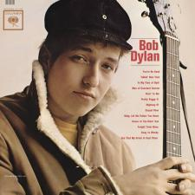
Bob Dylan
Bob Dylan is an American musician, singer-songwriter, artist, and writer. He has been an influential figure in popular music and culture for more than five decades. Much of his most celebrated work dates from the 1960s when he was an informal chronicler and a seemingly reluctant figurehead of social unrest. A number of Dylan's early songs, such as "Blowin' in the Wind" and "The Times They Are a-Changin'", became anthems for the US civil rights and anti-war movements. Leaving behind his initial base in the culture of the folk music revival, Dylan's six-minute single "Like a Rolling Stone" radically altered the parameters of popular music in 1965.

ATTENDEE BIOGRAPHIES

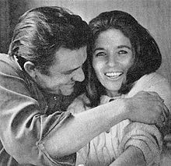
June Carter Cash
While June Carter Cash may be best known for singing and songwriting, she was also an author, dancer, actress, comedian, philanthropist and humanitarian.^{[6]} Director Elia Kazan saw her perform at the Grand Ole Opry in 1955 and encouraged her to study acting. She studied with Lee Strasberg and Sanford Meisner at the Neighborhood Playhouse in New York. Her acting roles included Mrs. "Momma" Dewey in Robert Duvall's 1998 movie The Apostle, Sister Ruth, wife to Johnny Cash's character Kid Cole, on Dr. Quinn, Medicine Woman (1993–1997), and Clarise on Gunsmoke in 1957.

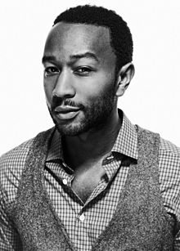
John Legend
John Roger Stephens, better known by his stage name John Legend, is an American singer-songwriter and actor. He has won nine Grammy Awards, and in 2007, he received the special Starlight Award from the Songwriters Hall of Fame. Prior to the release of his debut album, Stephens' career gained momentum through a series of successful collaborations with multiple established artists. Stephens added his voice to those of other artists, assisting in them reaching chart-topper hits. He lent his voice to Magnetic Man's "Getting Nowhere," Kanye West's "All of the Lights", on Slum Village's "Selfish" and Dilated Peoples' "This Way". Other artists included Jay-Z's "Encore", and he sang backing vocals on Alicia Keys' 2003 song "You Don't Know My Name", the Kanye West remix of Britney Spears' "Me Against the Music", and Fort Minor's "High Road". Stephens played piano on Lauryn Hill's "Everything Is Everything".

