

DCCC

Battleground Brief

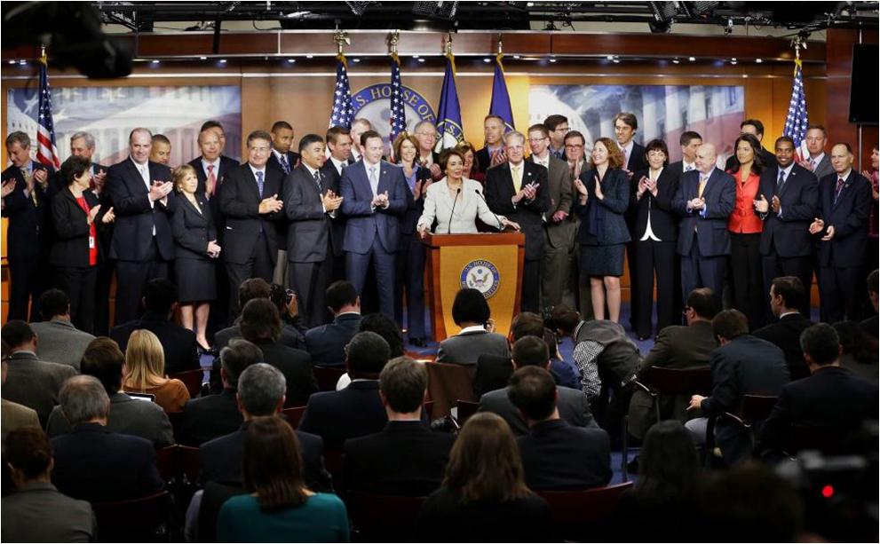

*The Democratic Freshman Class of 2012, with Leader Nancy Pelosi and DCCC Chairman Steve Israel*

**Democrats begin the 2014 cycle on strong footing, while Tea Party House Republicans have the honor of being the least popular majority ever.** January saw Democrats swear in the most diverse caucus in history—the first to be made up of a majority women and minorities—and remain united through budget fights in protecting Social Security and Medicare and standing up for the Middle Class. Meanwhile the Republicans began the 113th Congress deeply divided and dysfunctional. From the fiscal cliff to the debt ceiling, this Congress of Chronic Chaos has made brinkmanship routine. If the current Tea Party House Republicans keep this up for the next two years, our 2014 battlefield will continue to expand.

DCCC ACTIVITY:

* We have reached nearly 500,000 signatures on the [DCCC petition](http://www.dccc.org/page/s/end-gun-violence) supporting President Obama and calling on House Republicans to take action to prevent gun violence.
* We already have a recruitment committee in place, which has been meeting regularly since before the New Year. Members and DCCC staff [met with potential recruits](http://atr.rollcall.com/dccc-uses-inauguration-to-tout-potential-house-recruits/) in key districts over the Inauguration weekend.
* The DCCC released a video highlighting House Republican dysfunction as they embarked on their fence-mending conference retreat. Watch the video, “Kumbaya,” here:

[](http://www.youtube.com/watch?v=u7s5nzTCxpg&feature=youtu.be)

* Chairman Israel [released a statement](http://dccc.org/blog/entry/DCCC_Chairman_Steve_Israels_Statement_on_MLK_Day/) commemorating Martin Luther King, Jr. day, reminding us that “at a time when our country often seems ready to split at the seams, today we must remember Dr. King's mission to bring us together.”

RELEVANT NEWS:

* **The 113th Congress is the most diverse in history** “House Democrats became the first caucus in the history of either chamber not to have a majority of white men. It was a watershed moment for the Democratic Party, which…has marketed itself as the party that looks more like a fast-changing United States.” [The Washington Post, [1/3/13](http://articles.washingtonpost.com/2013-01-03/politics/36209417_1_diversity-democratic-party-presidential-election)]
* **House Democrats’ Art of War** “Steve Israel has been reading his Sun Tzu. The New York Democrat, who kicks off his second term as chairman of the Democratic Congressional Campaign Committee, has already begun an ambitious campaign to recruit candidates to run for Congress in 2014…Israel himself began recruiting on Election Night.” [The National Journal, [12/21/12](http://dccc.org/pages/the_national_journal_house_democrats_art_of_war)]
* **Republicans worry they’ll lose the House if they botch debt** **talks** “There’s growing angst among Republicans that the party’s House majority could be at risk in 2014 if the deep GOP divisions that emerged during the recent “fiscal cliff” negotiations persist in looming negotiations over a slew of budgetary issues.” [The Hill, [1/17/13](http://thehill.com/homenews/campaign/277655-republicans-worry-house-majority-in-danger-if-gop-botches-fiscal-talks)]
* **House GOP desperately seeking agenda** “The leadership has yet to cobble together anything resembling an agenda, and their members are complaining about what they describe as poor messaging…Republicans have also been operating entirely on the defensive against Obama, which worries many lawmakers.” [Politico, [1/15/13](http://www.politico.com/story/2013/01/house-gop-heads-to-retreat-seeking-elusive-agenda-86255.html)]
* **GOP looks for ways to stop the rape comments** “Rep. Phil Gingrey’s attempts to explain Todd Akin’s rape remarks are leaving many Republicans beyond frustrated that a few in their party can’t help but insert rape into the already contentious abortion debate.” [Politico, [1/11/13](http://www.politico.com/story/2013/01/gop-looks-for-ways-to-stop-the-rape-comments-86082_Page2.html)]
* **The myth of the six-year itch**  “The idea that there is something perilous about the sixth-year midterm, as opposed to the second-year midterm, isn’t really borne out by the numbers — particularly in the House. And if anything, the fact that Obama sustained huge losses in 2010 suggests his worst midterm is behind him, and the itch has been sufficiently scratched.” [The Washington Post, [12/3/12](http://www.washingtonpost.com/blogs/the-fix/wp/2012/12/03/the-myth-of-the-six-year-itch/)]
* **An Uneasy Turn at the G.O.P. Retreat** “Why, a final reporter prodded, did this panel on communicating with women and minorities include three white men: Representatives Adam Kinzinger of Illinois and Scott Rigell and Frank R. Wolf, both of Virginia?” [New York Times, [1/17/13](http://thecaucus.blogs.nytimes.com/2013/01/17/an-uneasy-turn-at-the-g-o-p-retreat/)]

BY THE NUMBERS:

* The Tea Party House Republican Congress is now less popular than head lice, traffic jams, cockroaches and root canals, [according to a PPP poll](http://www.publicpolicypolling.com/pdf/2011/PPP_Release_Natl_010813_.pdf) which puts Congressional approval at an historic low of 9%.
* [Gallup found](http://www.gallup.com/poll/159740/democrats-establish-lead-party-affiliation.aspx) that 47% of Americans identified as Democrats while only 42% identify as Republicans.
* President Obama and the Democrats won the fiscal cliff fight, and are winning the debt ceiling debate—while a plurality of Americans approved of the President’s handling of the tax fight, just 19% approved of Congressional Republicans handling, [according to a Pew poll](http://www.people-press.org/2013/01/07/obama-viewed-as-fiscal-cliff-victor-legislation-gets-lukewarm-reception/).

FLOOR ACTION:

* Sandy Relief Votes—After an embarrassing delay, Speaker Boehner brought a smaller portion of Sandy relief funds to the House floor for a vote, but 67 Republicans still voted against helping hurricane victims rebuild [HR 41, [Vote #7](http://clerk.house.gov/evs/2013/roll007.xml), 1/04/13].
* Speaker of the House Vote—House Republicans elected John Boehner Speaker of the House, but not before some last-minute floor drama that saw an aborted coup by disgruntled conservatives in his own party. And Boehner only garnered 220 votes out of his 232 member conference [New York Times, [1/03/13](http://www.nytimes.com/2013/01/04/us/politics/new-congress-begins-with-wishes-of-comity-but-battles-ahead.html?nl=us&emc=edit_cn_20130103&_r=1&)]

UPCOMING EVENTS:

* **Thursday, January 31, 2013**

**DCCC Political Update Dinner hosted by Lyn and Norman Lear**

Los Angeles, CA

Contact: Dan Boysen, [Boysen@dccc.org](mailto:Boysen@dccc.org), (202) 485-3448

* **Friday, February 1, 2013**

**DCCC Political Update Luncheon**

San Francisco, CA

Contact: Hannah Bruce, [bruce@dccc.org](mailto:bruce@dccc.org), (202) 485-3532

* **Sunday, February 3, 2013**

**DCCC 2013 Speaker’s Cabinet Super Bowl Brunch hosted by Frances and Calvin Fayard**

New Orleans, LA

Contact: Amelie LeBreton, [lebreton@dccc.org](mailto:lebreton@dccc.org), (202) 485-3403

* **Monday, February 11, 2013**

**Chairman Israel’s New York Political Update**

New York, NY

Contact: Jocina Becker, [becker@dccc.org](mailto:becker@dccc.org), (202) 485-3415

* **Monday, February 11, 2013**

**DCCC Speaker’s Cabinet Dinner**

Boston, MA

Contact: Megan Nashban, [Nashban@dccc.org](mailto:Nashban@dccc.org), (202) 741-1846

* **Wednesday, February 13, 2013**

**DCCC Reception Hosted by Elmendorf Ryan**

Washington, DC

Contact: Mike Smith, [smith@dccc.org](mailto:smith@dccc.org), (202) 485-3504

* **Wednesday, February 20, 2013**

**DCCC Dinner hosted by Raysa and Alfy Fanjul and Rep. Frankel**

Palm Beach, FL

Contact: Amelie LeBreton, [lebreton@dccc.org](mailto:lebreton@dccc.org), (202) 485-3403

* **Saturday, February 23, 2013**

**DCCC Lunch Hosted by Rep. Castro**

San Antonio, TX

Contact: Amelie LeBreton, [lebreton@dccc.org](mailto:lebreton@dccc.org), (202) 485-3403

* **Saturday, February 24, 2013**

**DCCC Reception Hosted by Rep. Cuellar**

Laredo, TX

Contact: Amelie LeBreton, [lebreton@dccc.org](mailto:lebreton@dccc.org), (202) 485-3403

* **Monday, February 25, 2013**

**DCCC Dinner Hosted by Heather and Tony Podesta**

Washington, DC

Contact: Becca Durr, [durr@dccc.org](mailto:durr@dccc.org), (202) 485-3445

* **Tuesday, February 26, 2013**

**DCCC Dinner Hosted by Nancy and Harold Zirkin**

Chevy Chase, MD

Contact: Becca Durr, [durr@dccc.org](mailto:durr@dccc.org) , (202) 485-3445

* **Sunday, March 10, 2013**

**DCCC Dinner Hosted by Dr. John Sperling**

Phoenix, AZ

Contact: Dan Boysen, [Boysen@dccc.org](mailto:Boysen@dccc.org), (202) 485-3448

* **Friday, March 22, 2013- Saturday, March 23, 2013**

**DCCC Annual New York Issues Conference**

New York, NY

Contact: Molly Perkins, [perkins@dccc.org](mailto:perkins@dccc.org), (202) 485-3508

* **Tuesday, April 2nd, 2013**

**2013 Speaker’s Cabinet and Pelosi 100 Dinner at the Home of Ann and Gordon Getty**

San Francisco, CA

Contact: Lisa Presta, [lisapresta@yahoo.com](mailto:lisapresta@yahoo.com), (415) 681-1049