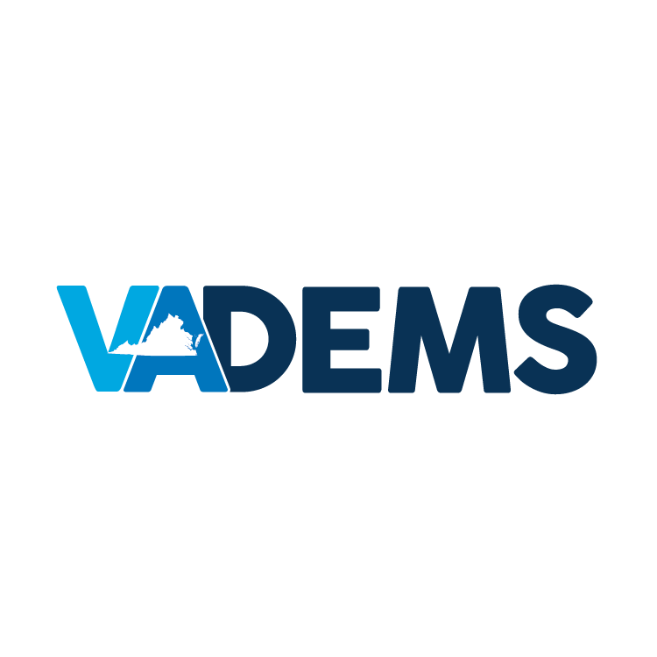

DEMOCRATIC PARTY OF VIRGINIA – SPONSORSHIP PACKAGES
2016 DEMOCRATIC NATIONAL CONVENTION
PHILADELPHIA, PA – JULY 25-28, 2016

BEER GARDEN EVENT AT THE LIBERTY BELL
$25,000
CO-CHAIR

4 VIP tickets for event clutch

15 preferred tickets and open bar

Company logo prominently displayed at event and special recognition

$50,000
CHAIR

8 VIP tickets for event clutch

25 preferred tickets and open bar

Company logo prominently displayed at event and special recognition

$5,000
SUPPORTER

5 preferred tickets and open bar

Company logo displayed at event and special recognition

$10,000
FRIEND

1 VIP ticket for event clutch

8 preferred tickets and open bar

Company logo displayed at event and special recognition

$15,000
HOST

2 VIP tickets for event clutch

10 preferred tickets and open bar

Company logo displayed at event and special recognition

OTHER GIVING OPPORTUNITIES
$30,000
DELEGATION BREAKFAST

Exclusive sponsorship of 1 breakfast

Opportunity to address VA delegation before daily voting

Company logo displayed at event and special recognition

$20,000
TRANSPORTATION

Sponsor statewide transportation to and from Philadelphia

Company logo displayed and special recognition

$10,000
VA HEADQUARTERS

Sponsor office for staff and
elected officials

Company logo displayed at office and special recognition

Transportation ($10,000)

Paid for by the Democratic Party of Virginia. Not authorized by any candidate or candidate’s committee.
vademocrats.org – 919 East Main Street, Suite 2050, Richmond, VA 23219

