Skip to content

Fiona Barnett
An Australian Experience of Ritual Abuse & Mind Control
Menu
Search
- Latest
- Welcome
- Candy Girl
  - Royal Whitewash
  - Ritual Abuse in Australia
  - Certified Sane
  - The Justice Myth
- Abuse Drawings
- News Articles
  - Senator Bill Heffernan uses parliamentary privilege to accuse former PM of being alleged paedophile
  - Political elite were part of paedophile ring, alleged victim Fiona Barnett claims
  - Franca Arena was right on the mark
- Links
- Documentary
- Media Interviews
  - Lift the Veil, 1 August 2018
  - The Crazz Files, 20 Feb 2016
  - The Richie Allen Show, 3 December, 2015
  - The Richie Allen Show, 30 October, 2015
  - The Opperman Report, 19 December, 2015
  - Integrity News Network, 11 December, 2015
  - Cancel the Cabal, 16 December, 2015, with David Shurter
  - Cancel the Cabal, 24 December 2015, with David Shurter
  - Cancel the Cabal, 6 January 2016, with David Shurter
- MK-Ultra, ASIO, CIA
  - Kim Beazley Senior: ASIO Agent and Child Trafficker
  - MK-ULTRA in Australia: Part 1
  - MK-ULTRA in Australia: Part 2
  - KIDMAN, Trauma Research & His Abuse of Fiona Barnett
  - Kidman Connections: The CIA, Secret Societies & Ritual Abuse
  - Australian False Memory Association Exposed
  - MK-ULTRA in Australia: Part 3
  - MK-ULTRA in Australia: Part 4
  - MK-ULTRA in Australia: Part 5 – MK-NAOMI and Dr Petrauskas
  - MK-ULTRA in Australia: Part 6

Search for:Search

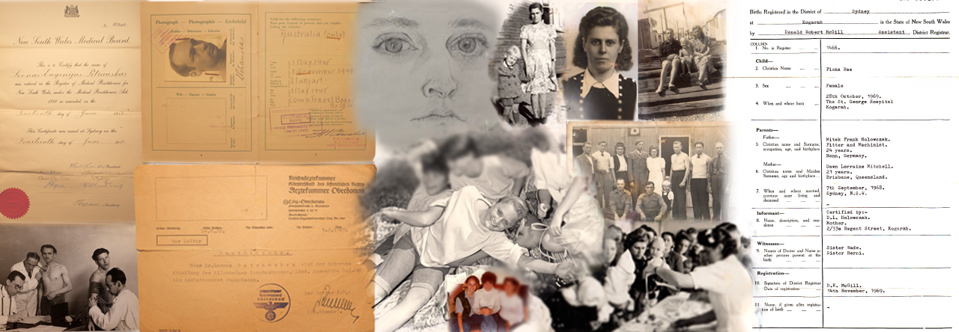

Abuse Drawings
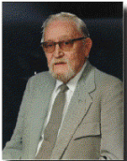
MK-ULTRA Psychologist John Gittinger

Note – the Australian government continues to hack and remove my abuse drawings. I expect this is because I get up to 100,000 views per day of this page. Each time they disappear, alert me in the comments section to this page and I will restore them and let WordPress know. Otherwise, visit other sites like Cathy Fox’s blog where you will find a copy.

Originally posted on 29 November 2015:
Hang on for the ride!
Part 1:
Prostituted by the Australian government to RICHARD NIXON at RAAF Fairbairne military airport, Canberra. The Australian Federal Police unit ‘Operation Attest’ refused to investigate this incident. They promised to at least investigate and tell me whether or not there was a centrifuge at the base, used to train pilots in – to validate my memories. An ex-military perosn who worked at the base validated its existence instead.
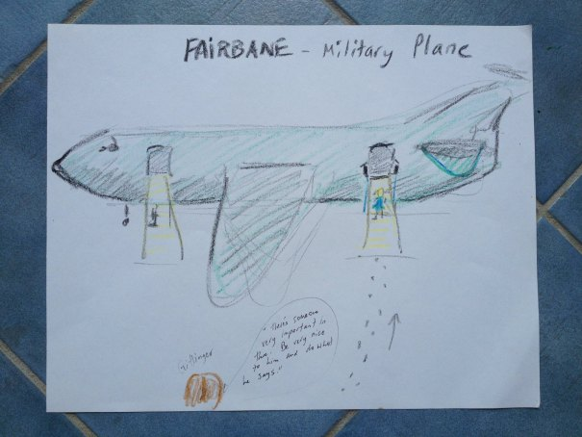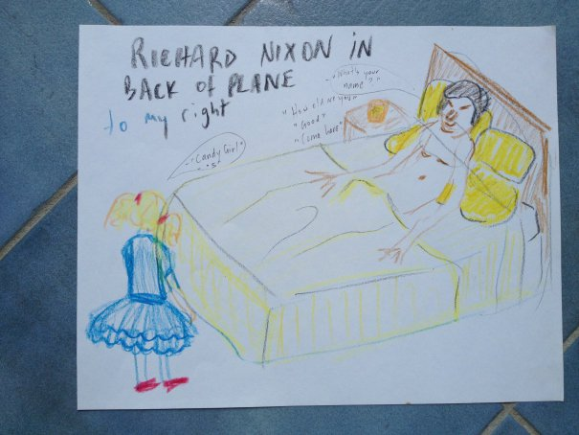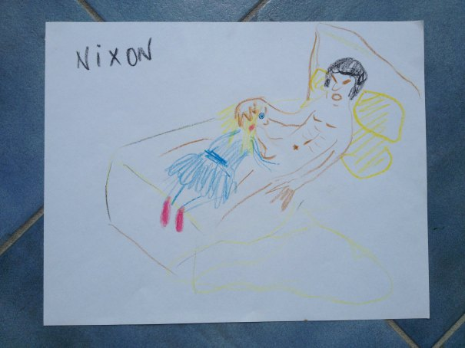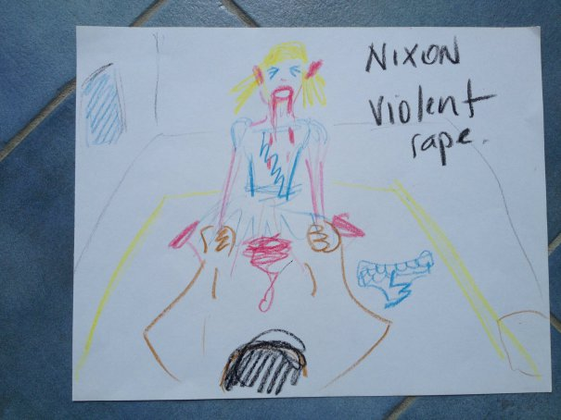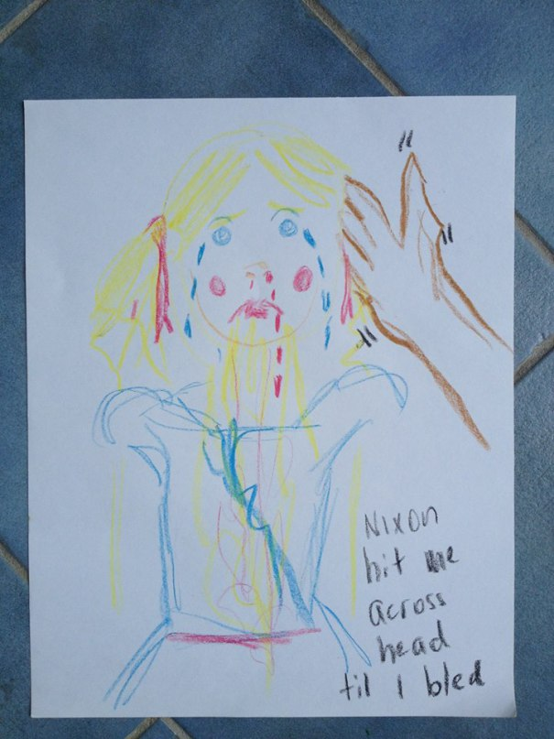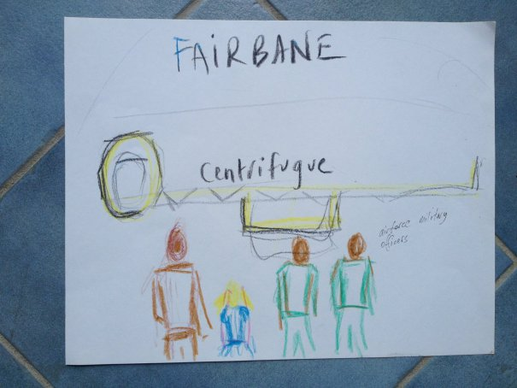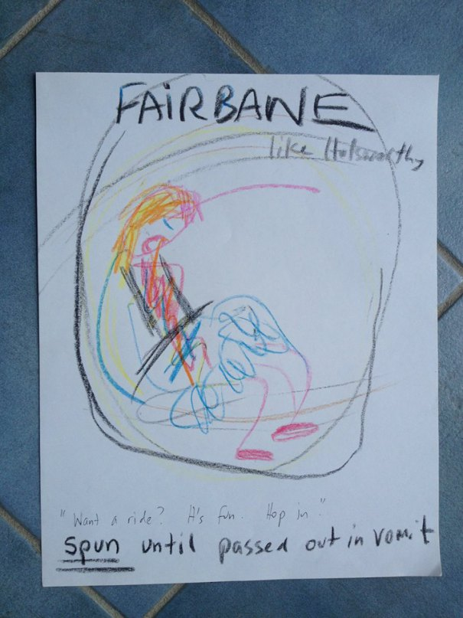
Hang on for the ride! Part 2:
Being used as a guinea pig, subjected to child rape, electrocution & torture at Holsworthy Army Base & Lucas Heights nuclear reactor, for the JASON PROJECT by John GITTINGER and Dr Antony KIDMAN – with the full knowledge and approval of the Australian Government.
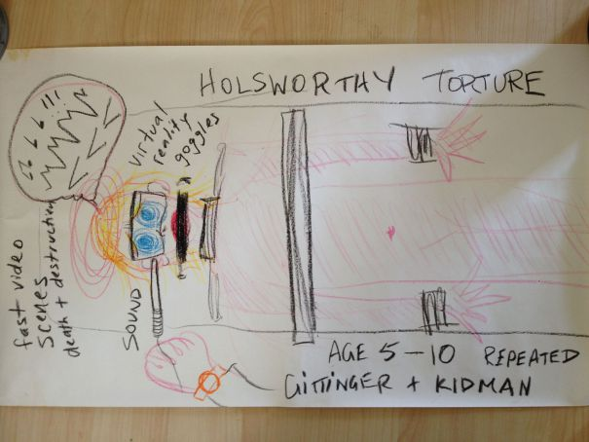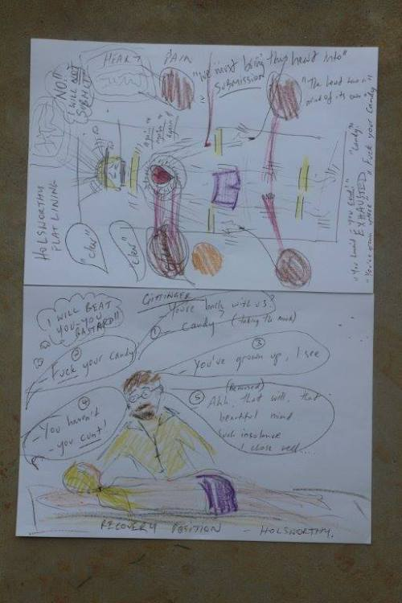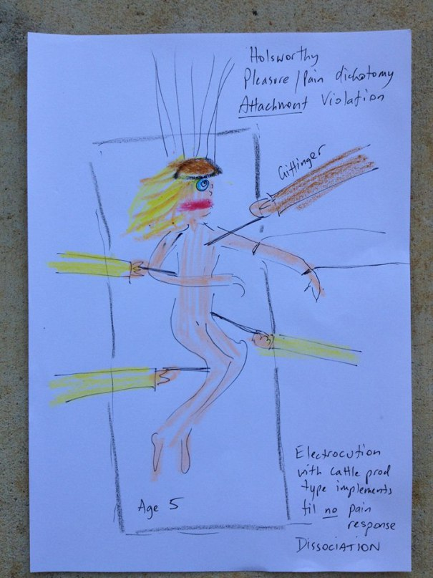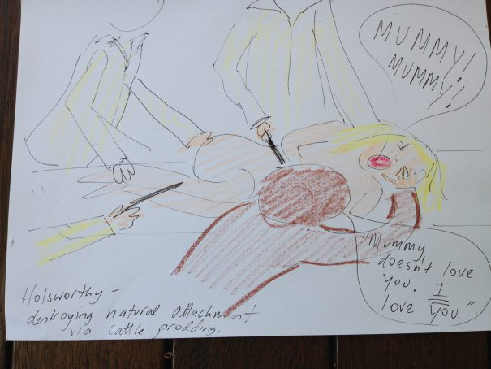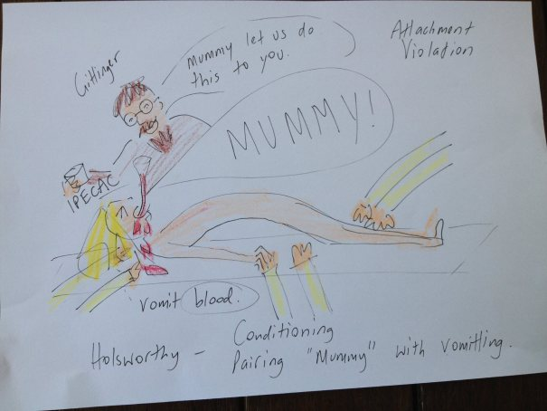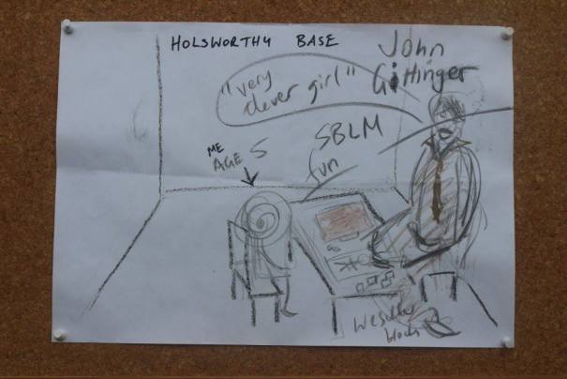
Hang on for the ride! Part 3
A former Holsworthy officer confirmed that an Asian man named named Chan was recruited in the army at Holsworthy. This man is thought to have been in the Army Reserves, but when I saw him he appeared to outrank all the Australian soldiers I witnessed under his command. Chan received the dead body of a girl named Michelle who was abducted by Engadine Boystown pedos, murdered beside the Weir on Heathcote Rd, and delivered to Chan through a side gate at Holsworthy.
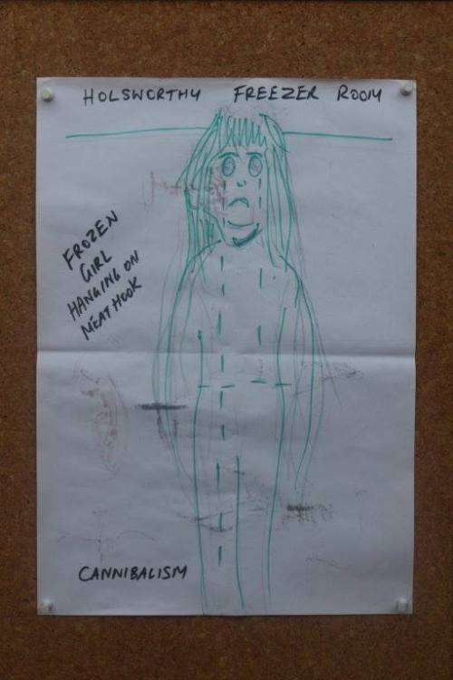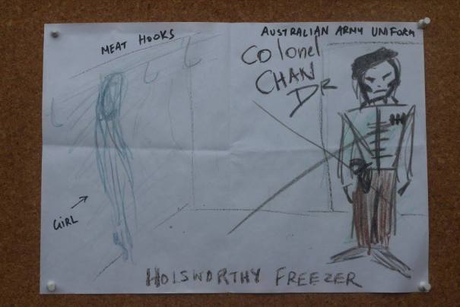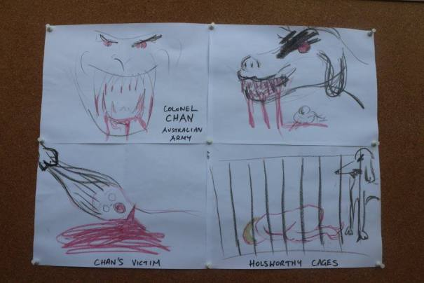
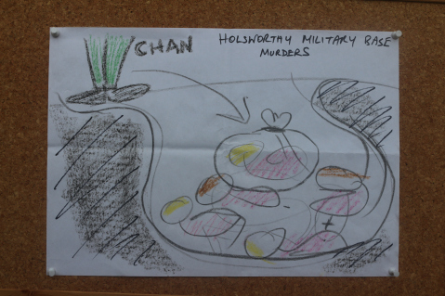
Hang on for the ride! Part 4
Dr ANTONY KIDMAN was trained by Gittinger and others in the employment of torture, unethical hypnosis, and drugs to artificially induce a state of dissociation in children. He also was in a kiddie killing cult. His MK-Ultra programming was structured on a pentagram – the same emblem that featured in his inner Sydney City cult and Kidman’s local ‘Order of the Easter Star’ Freemason Lodge that burnt down immediately after I first went public.
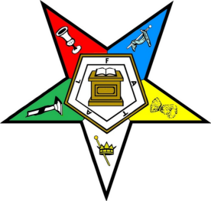
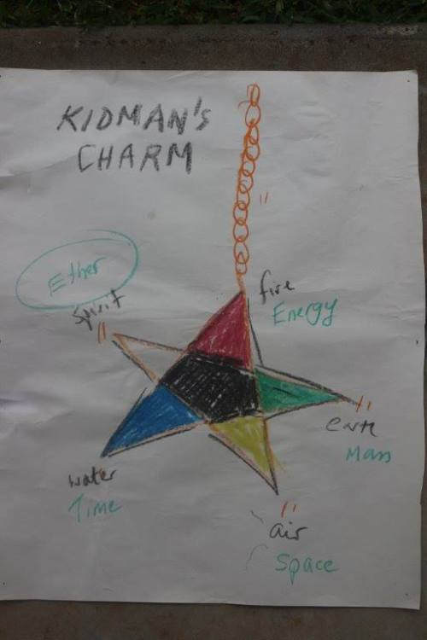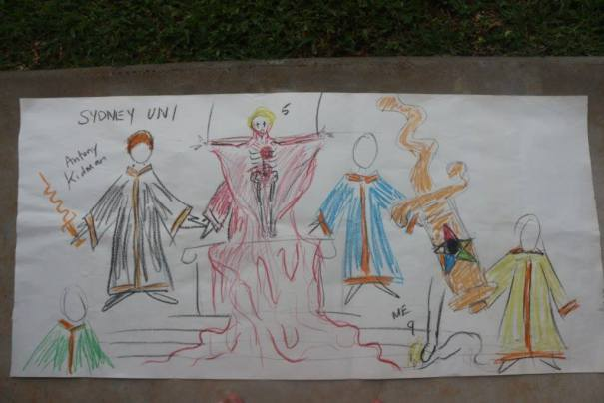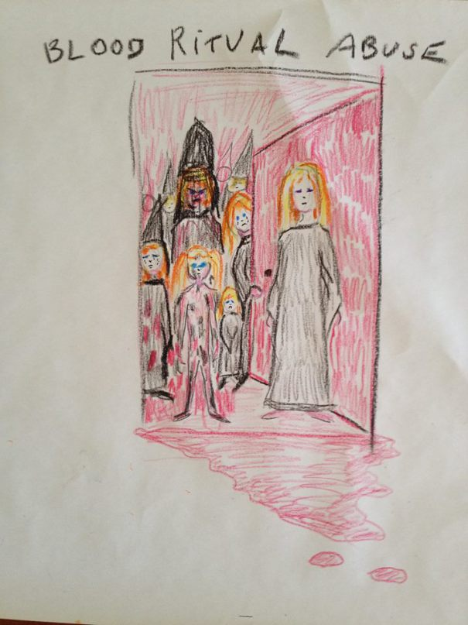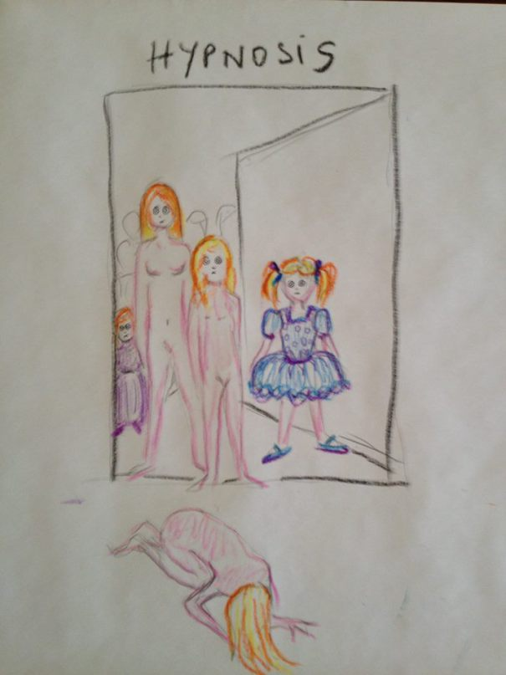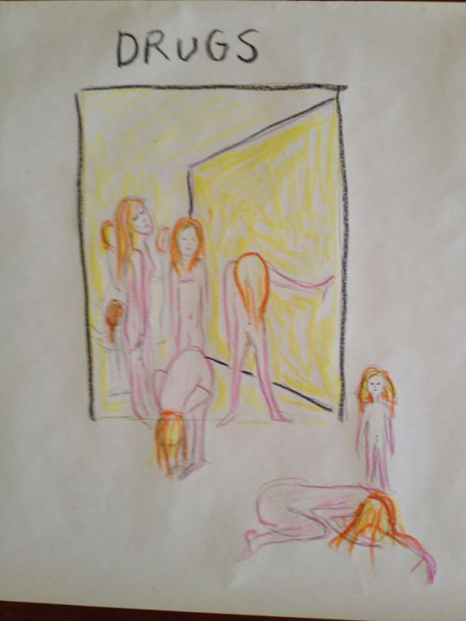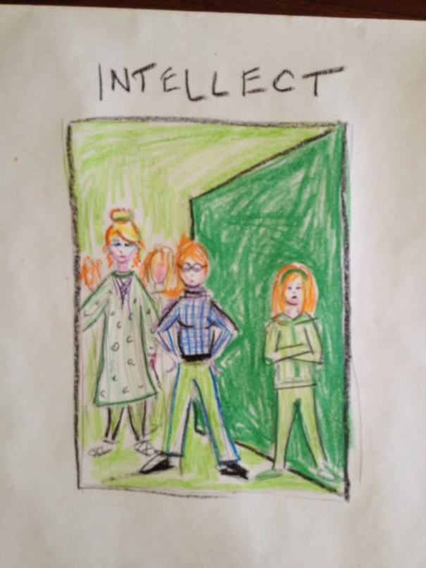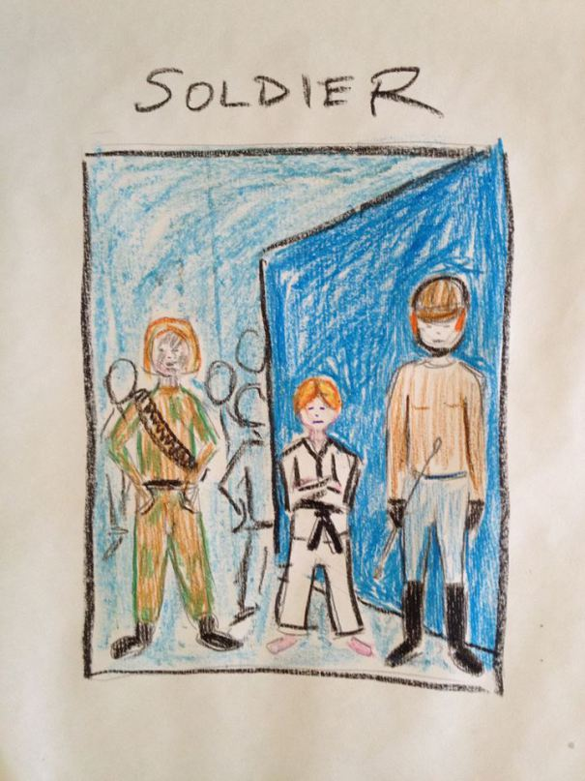
Hang on for the Ride! Part 5
Prime Minister GOUGH WHITLAM & his lover Governor General JOHN KERR raped me at a pedo party at Parliament House. Operation Attest refused to investigate this on the grounds they are dead – even though that federal police task force was established to investigate HISTORICAL child sex offences.
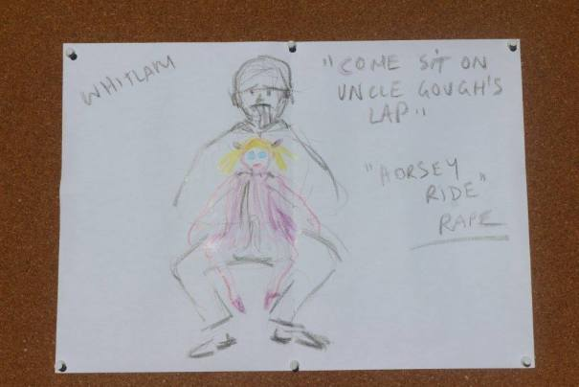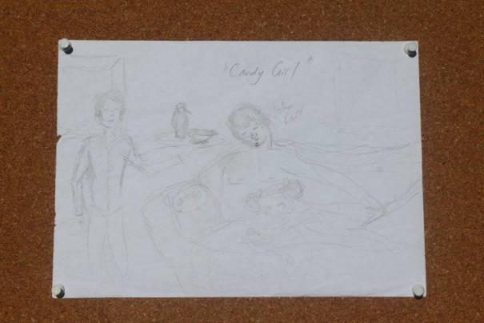
Hang on for the ride! Part 6
I was trafficked to the USA, to Bohemian Grove where I was drugged & raped by the Rev BILLY GRAHAM – Richard Nixon’s pal, in a pink bubble room. I was also made to dress up like a teddy bear and play hide, seek & rape. I also witnessed the ritual murder of a person by politicians dressed up in robes. I was taken via Sydney airport, in a crate like an animal. On the way home I was drugged, raped and beaten at an exclusive, after hours, pedo gathering at Disneyworld. Yes, Walt Disney was a pedo. Why do you think the Mickey Mousketeers go nuts and shave their heads? Why did pedo Whacko Jacko build a Neverland based on Disneyland?
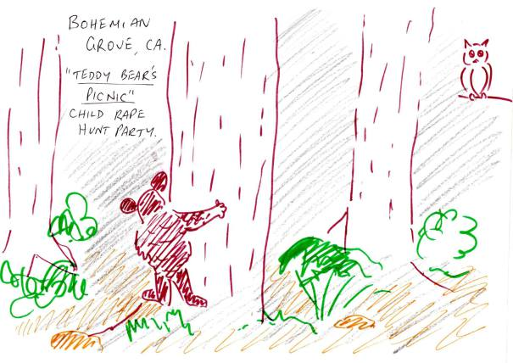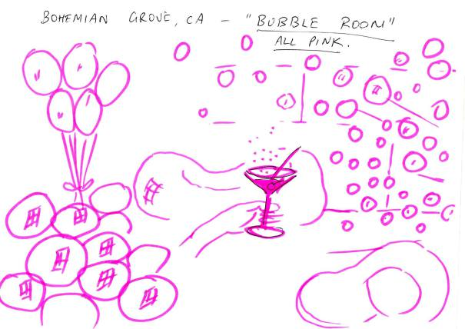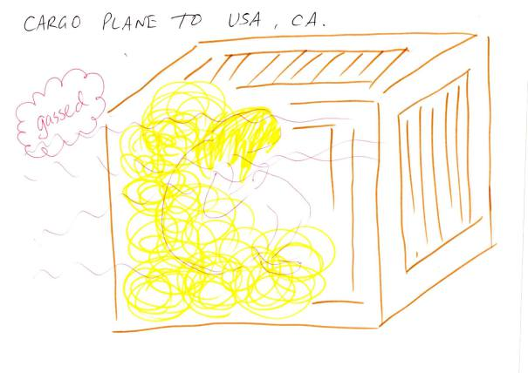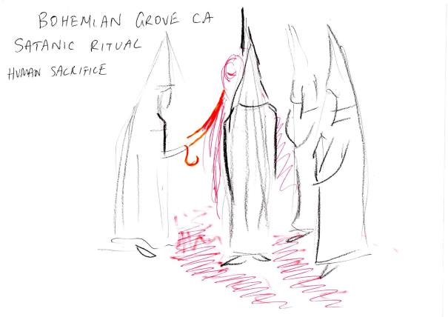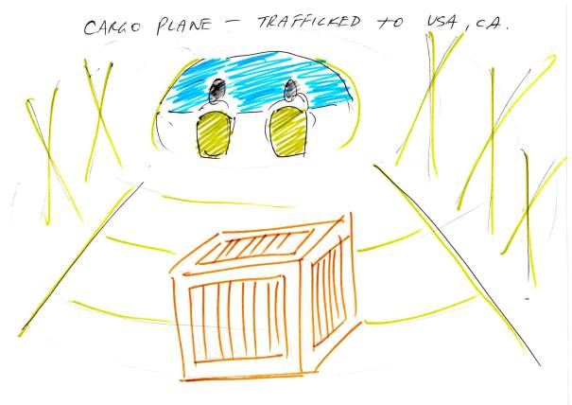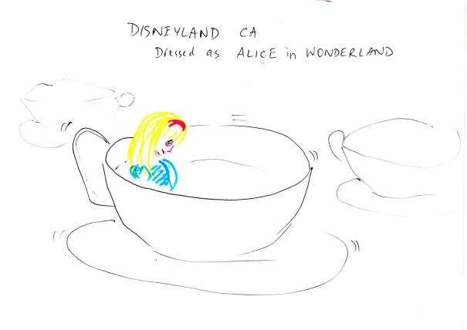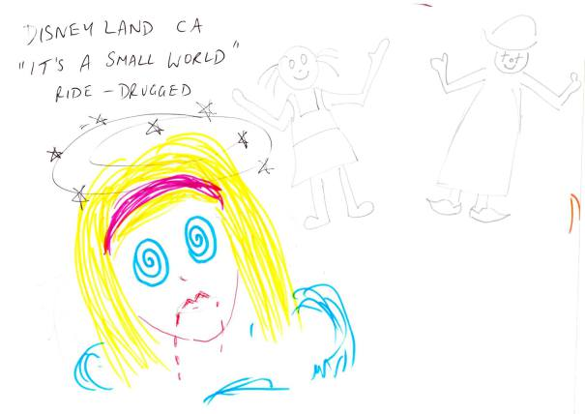
Hang on for the ride! Part 7
Yes, ritual abuse does exist in Australia. A kiddie killing cult underpins the Roman Catholic Church, Engadine BoysTown, Holsworthy Army Base, Lucas Heights nuclear reactor. Here are the only photos I can present as evidence. First we have Leonas Petrauskas (aka Dr Mark) performing an abortion on me beneath Engadine BoysTown. Next we have the statue of ‘DAGON’ located on the ground floor of the 6-7 story underground facility at Holsworthy, located far from the main entrance gate. Then we have Dagon statue in fish form, kneeling beside a murky pool, on the ground floor of Lucas Heights nuclear reactor. Lucas Heights, like Pine Gap, are CIA facilities where the Jason Project was conducted. Both facilities were built by the same group.
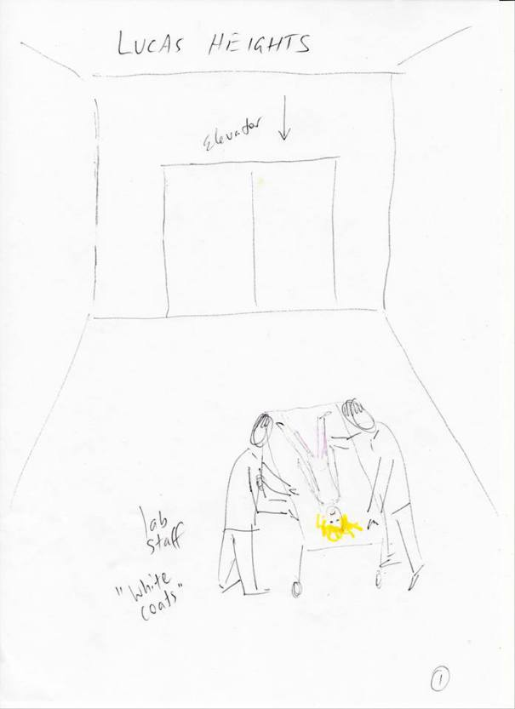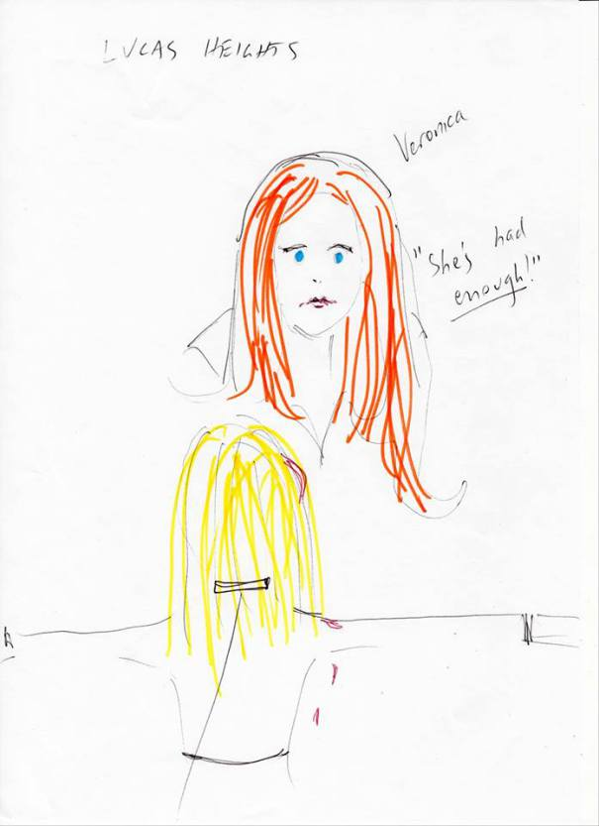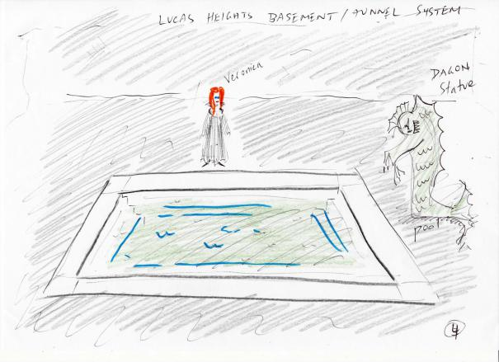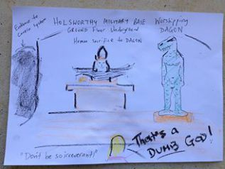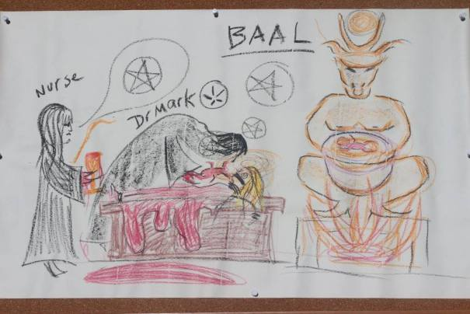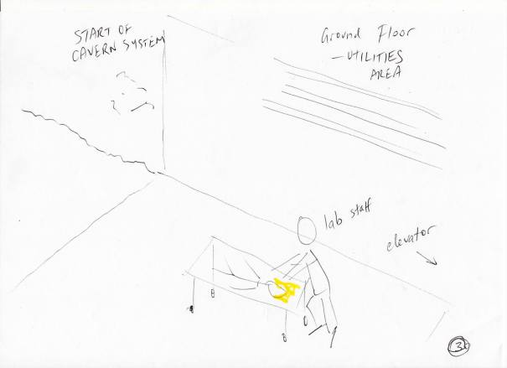
Hang on for the ride! Part 8
Here’s a couple of cult rituals to their god ‘Moloch’ – the same one they pretend to sacrifice humans to at Bohemian Grove. Apparently, according to their religious beliefs, Moloch is happy when people are burnt alive in his name. One took place at Caltex Oil Refinery at Kurnell. The other on a remote Kurnell Beach.
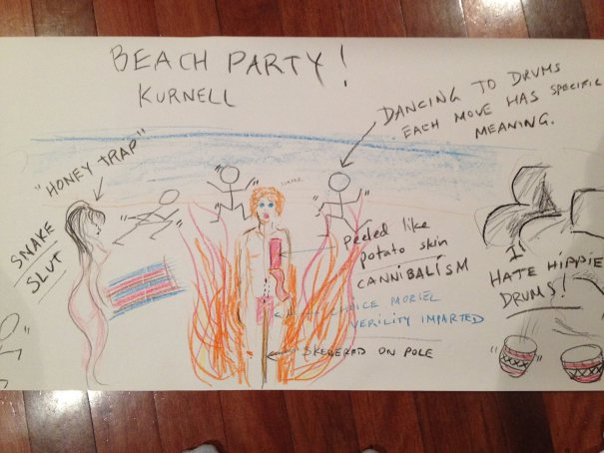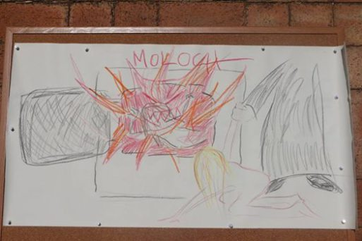
Hang on for the ride! Part 9
And here is the nicest person I met in the pedo organisation – Grande Dame Veronica. No idea if that was her true name, considering they changed peoples’ names so I couldn’t ID them easily later. Veronica was my surrogate mother, tutor, mentor within the pedo network, from age 5 until age 14 when she was ritually murdered on the altar at St Mary’s cathedral in Sydney City. The church was packed full of Sydney’s social elite. An organ played, a choir sang, police guarded the doors. Veronica chose to die young because she was sick of abusing children like me. She was a victim forced to turn perpetrator. She lived in private living quarters at Sancta Sophia College at Sydney University.
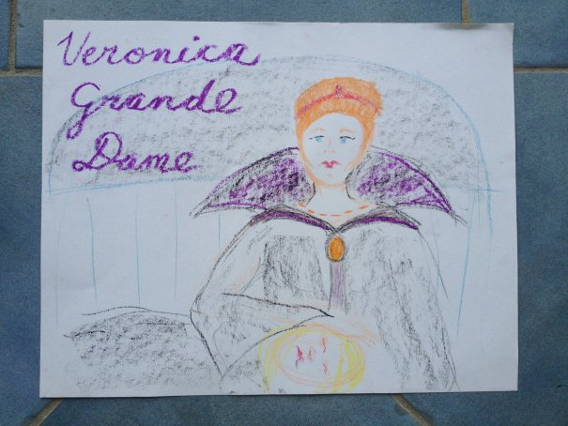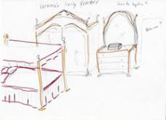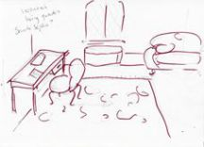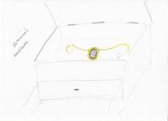
Hang on for the ride! Part 10
And here’s my favourite – the one that epitomises the Australian government’s attitude toward government-sanctioned child trafficking, rape and murder in this country.
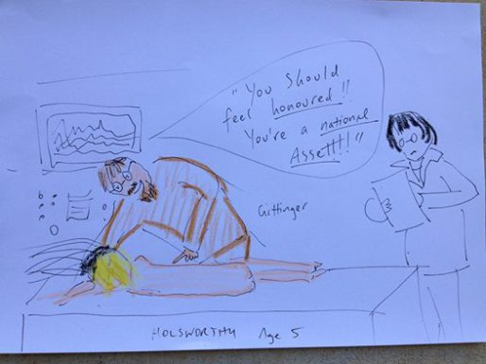
Hang on for the ride! Part 11
And now for something completely different! Some more Holsworthy secrets – an underground railway connects major sites in Australia, including Pine Gap, Lucas Heights/Holsworthy. Also, Gittinger used some kid of prop/virual reality program called Candyland, which had ‘Disney’ trademark written on it
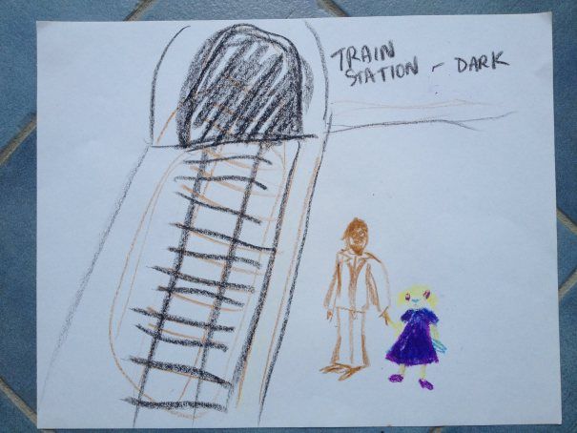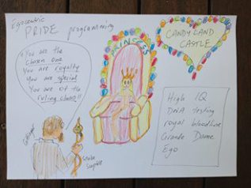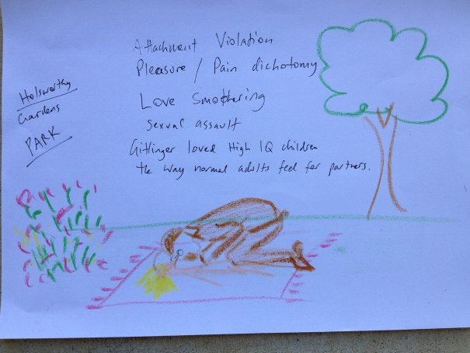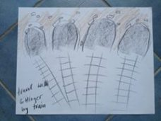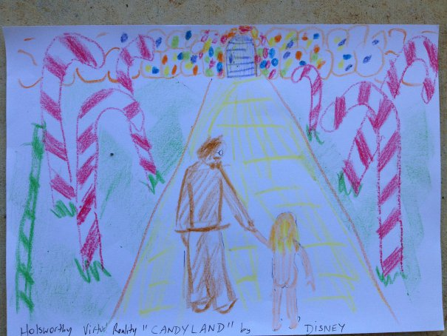
Hang on for the ride! Part 12
And now for the pista resistance! At age 5 I was raped by future Prime Minister BOB HAWKE in a zucchini patch, at a BBQ, in a suburban Canberra backyard.
Another Bob Hawke victim, the daughter of Hawke’s architect Kevin Borland, was assaulted by Hawke after a party at her family home when she was 14. Hawke entered her room at night, awoke her in her bed, and digitally penetrated her. She immediately told her entire family who recall the incident today.
When I was 8, Dr Leonas Petrauskas took me to a crime scene at a secluded Kurnell Beach. There he met with prime minister Paul Keating who had raped and murdered a 5 year old boy and shallowly buried him in the sand. Keating was into necrophilia. Petrasukas was called in by Keating to do a clean up job. Petrauskas ordered me to dig up the body. As I did this, I heard the men talking about Petrauskas fabricating the child’s cause of death as a blue ringed octopus sting.
Operation Attest lied in their response to my complaint, saying they would not investigate mt claims because the alleged perpetrators were all dead. Last I checked, Keating and Hawke were still alive.Hang on for the ride! Part 13
I was also raped by actor BRUCE SPENCE, at Bathurst City Hall when I was 15. I met an apprentice carpet layer who laid carpet in Spence’s Sydney flat. He said Spence’s lounge room walls were covered in kiddie porn.
I was also raped by Shakespearean actor JOHN BELL, in the company of Dr Antony Kidman, on the eve of my 15th birthday, after a Nimrod Theatre post production party held at Kidman’s house that was attended by the Shakesperean play’s well-known cast. The following morning, Kidman tied me to a chair and beat me in front of his daughter NICOLE KIDMAN who stood there and smirked at me, with her arms crossed.
I witnessed actress JACKI WEAVER, playwright JOHN WILLIAMSON, and author of Puberty Blues KATHY LETTE at pedo ritual gatherings in Sydney. Kathy was based at Regina Coeli cathedral in Beverly Hills.
Other victims have identified Jacki Weaver to Dr Reina Michaelson, on whom the Australian Government placed a D Section gagging order, on the grounds that her disclosure of the government’s involvement in child trafficing etc would undermine the Australian public’s confidence in the Australian government.
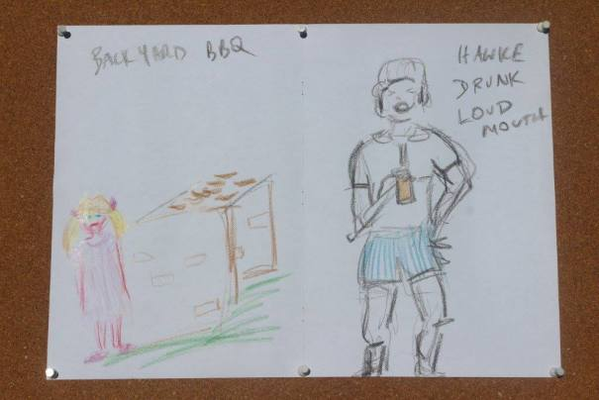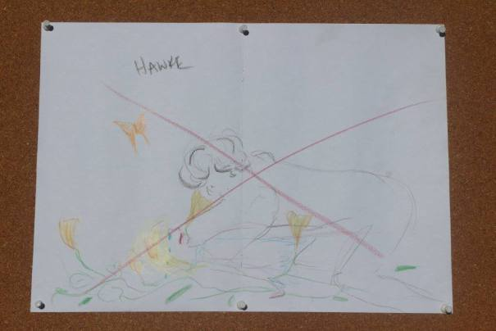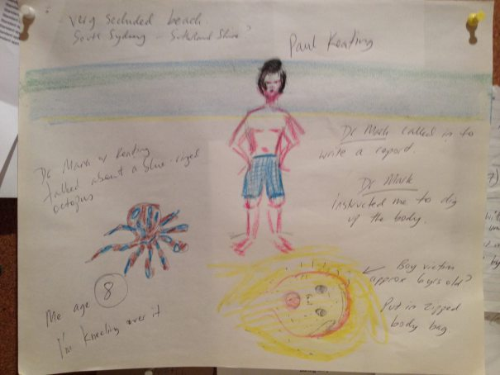

My statement concerning my 13 ‘Hang on for the Ride’ posts:
My reasons for posting this information is as follows:
1. With the exception of the 2 detectives who took my statements in Sydney on 2-3 November 2015 – the NSW Police force have refused to protect me from my neighbour who moved next door from Wollongong 10 years ago. Ever since then, he has assaulted my family, poisoned my dog, constantly harassed and intimidated and threatened my family including 2 children. Further, police have targeted me for harassment during the past 10 years since I advocated for the many children abused by the Tweed Shire pedo ring.
2. I know from past experience that the 2 good officers who took my statements will be prevented from doing their job and investigating my claims. Dr Reina Michaelson attests that she witnessed a good female officer’s career destroyed by her command, because she pursued claims of ritual abuse and VIP pedo network in Victoria involving politicians, police, Channel 10 making kiddie porn, etc. I do not want these good officers attacked from within like Peter Fox was. Peter Fox’s police command rang his private doctor and insisted she declare Peter Fox medically insane.
3. Many victims of the same VIP pedophile network that I described to police have contacted me in the past month. Not one of the stronger capable group of these people have publicly supported me by joining me and speaking out. Consequently, the pedophile network have severely targeted me. I believe my life is at risk because the police and Royal Commission have failed to support me with witness protection.
4. I am exhausted. I have no other means of protecting my family other than sharing the information that places my family at risk as long as it remains a secret. It is out now – perhaps now my husband and children are safe.
5. I share this information so that other victims may recognise their own abuse experiences and know that they are not crazy, not alone – that YES this did happen to them.
6. Most importantly – I speak out to give a voice to the 100+ children I witnessed raped, tortured and murdered throughout my nightmare childhood. I saw children bred in captivity beneath Holsworthy to be used as human guinea pigs in horrendous unethical medical experiments – all in the name of national security. THESE CHILDREN DID INDEED EXIST!!
7. I would like to thank my supporters, including SNAP and others – they know who they are.
8. And now, on a deeply personal note – I acknowledge that many victims have been abused in the name of religion. God is not reflected in churchianity, Hillsong, the Roman Catholic Church, or any of the other infiltrated organisation. I know that many victims reel when I mention God, which is why I have avoided it. But many people ask me, what is the source of my strength and hope. My strength, perseverance and survival are a testimony to the existence and authority of God and His only Son Jesus Christ. That is what I believe. That is all I have to offer besides my witness testimony. That is all I had to comfort me throughout my abuse.

Share this:
- Twitter
- Facebook318
- Google

Like this:

Search for: Search

Top Clicks
- pedophilesdownunder.com/2…
- pedophilesdownunder.com/2…
- washingtonpost.com/world/…
- kiwiannas.wordpress.com
- pedophilesdownunder.com/2…
- amazon.com/Babylonian-Fun…
- cathyfox.files.wordpress.…
- pedophilesdownunder.com/2…
- pedophilesdownunder.com/2…
- pedophilesdownunder.com/2…

Recent Comments
The Nightingale File… on Rachel Krause’s Criminal…
don burton on Fiona Barnett’s ITNJ…
don burton on Fiona Barnett’s ITNJ…
ill on WARNING! Ruby Slippers Psy-Op…
Roslyn Mitchell on Australian Human Rights Commis…

Follow me on Twitter

Categories

Categories

Archives
- September 2018
- August 2018
- July 2018
- June 2018
- May 2018
- September 2017
- August 2017
- January 2017
- December 2016
- September 2016
- August 2016
- July 2016
- May 2016
- April 2016
- February 2016

Search for: Search

Social Media
- View fiona.barnett.940’s profile on Facebook
- View @FionaRaeBarnett’s profile on Twitter

Meta
- Register
- Log in
- Entries RSS
- Comments RSS
- WordPress.com
Blog at WordPress.com.

Post to
Cancel

- Follow

  - Fiona Barnett
  - Customize
  - Follow
  - Sign up
  - Log in
  - Copy shortlink
  - Report this content
  - Manage subscriptions
  - Collapse this bar
%d bloggers like this:
<img src="https://pixel.wp.com/b.gif?v=noscript" style="height:0px;width:0px;overflow:hidden" alt="" />

